Links -

<https://www.geeksforgeeks.org/system-design/system-design-tutorial/>

Videos -

System Design –

Load Balancer, API Getway, Cache, Queue, Broker, High ThroughPut, VPC

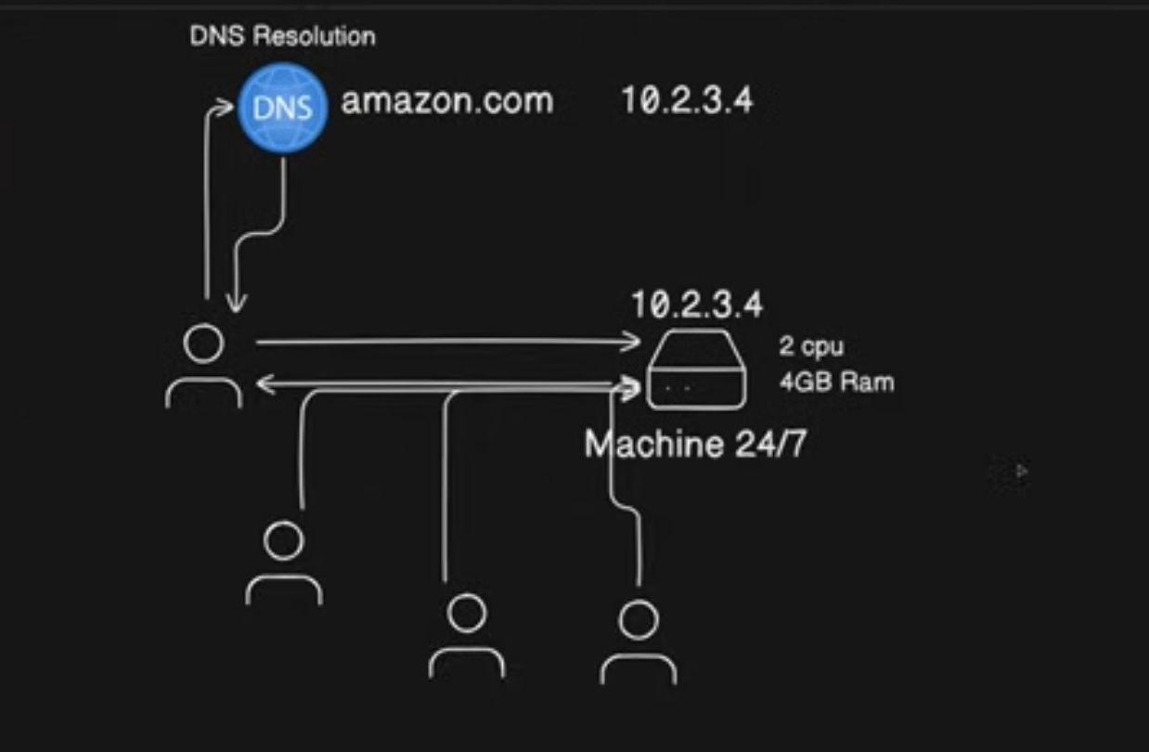

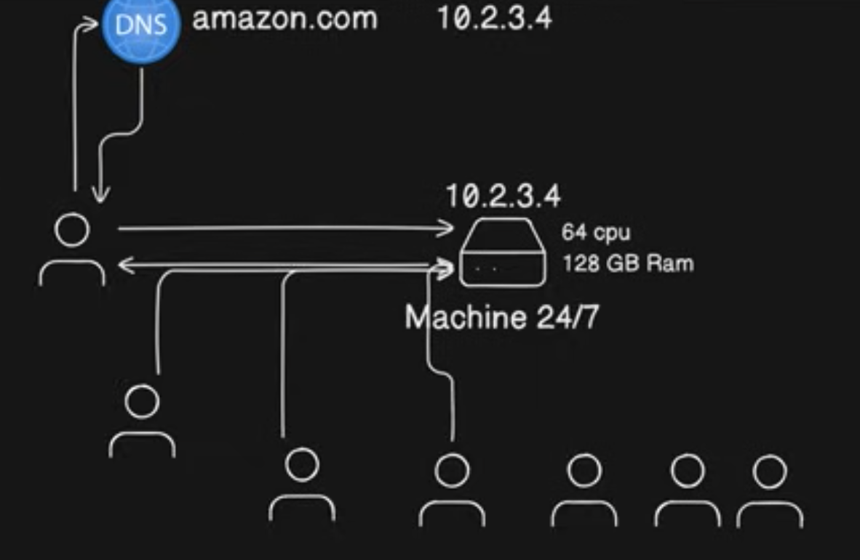

Amazon traffic pattern?

Vertical Scaling – Ismein downtime aata agar aap vertical scaling kar rhe ho toh.

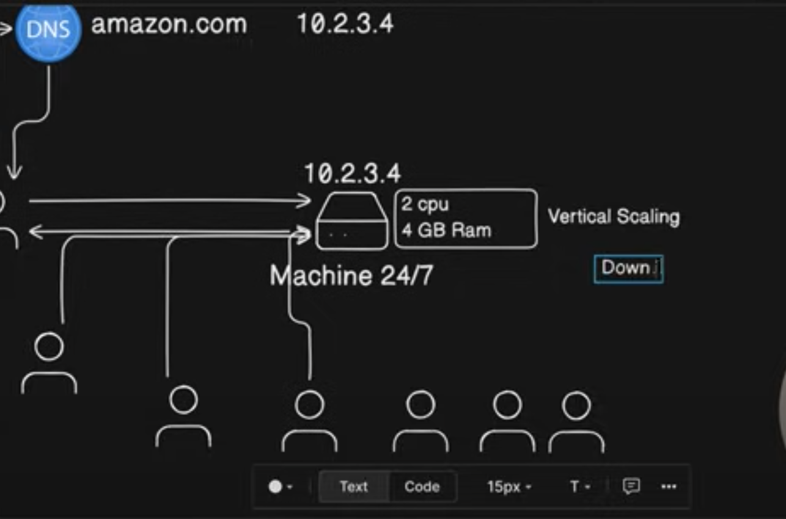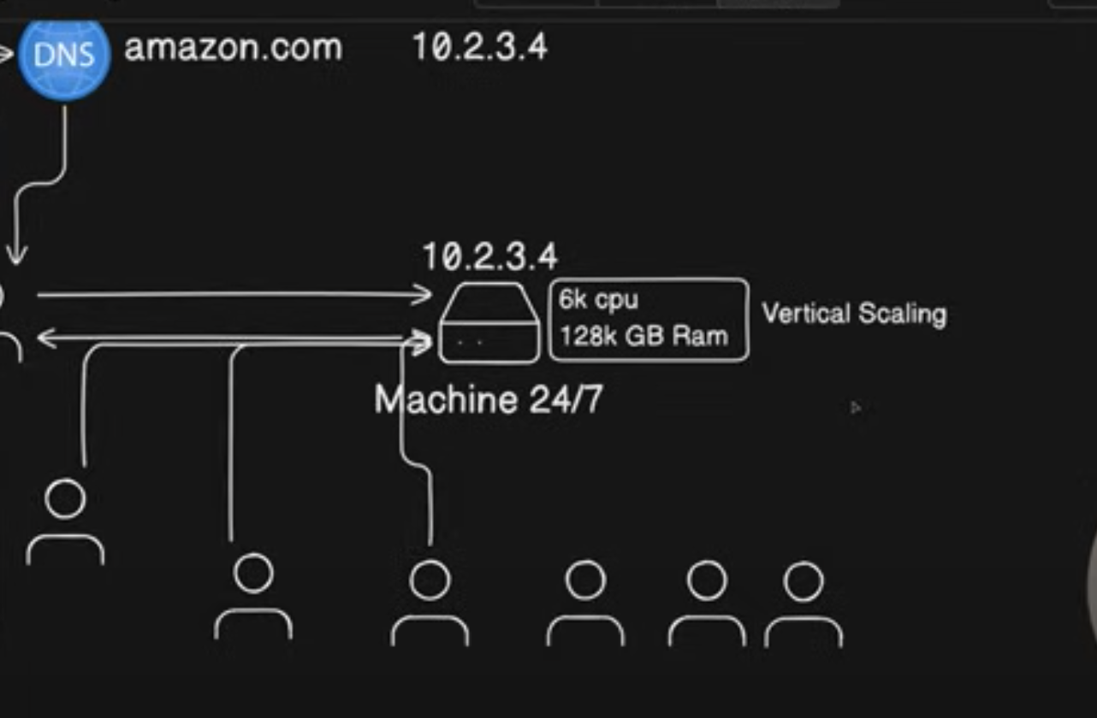

Horizontal scaling mein downtime zero hota hai – true. But performance still might be slow becaue you have 2 machines to handle traffic of 4 toh jab tak baaki ki 2 machines boot up hongi tab tak yeh 2 machines slowly handle karengi traffic. This way zero down time is ensured.

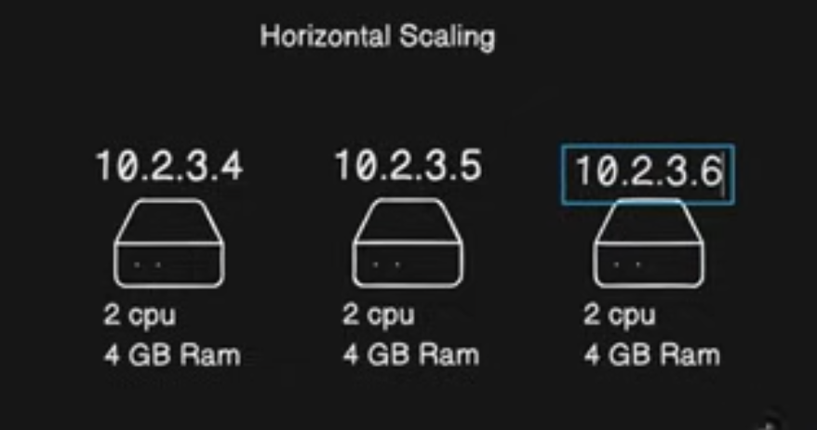

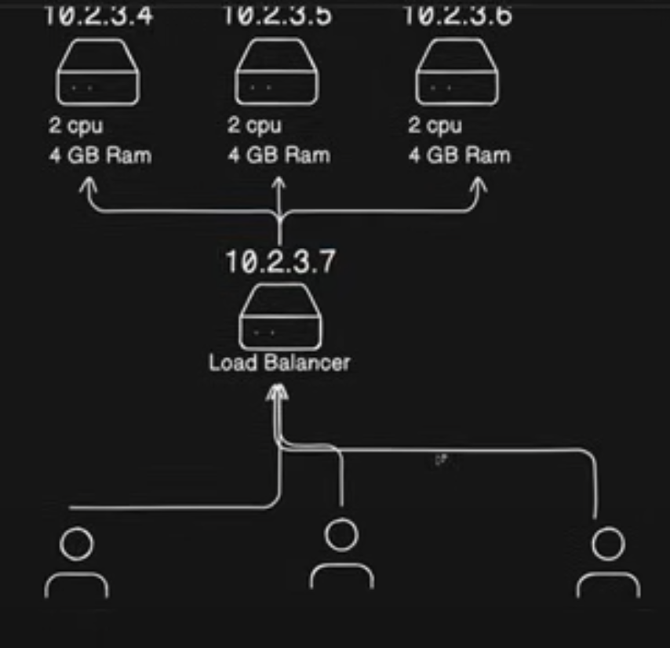

Load Balancer Methods – Round Robin, Weighted,

DNS => Load Balancer IP

Elastic Load balancer – Agar koii machine traffic lene ke liye healthy hai tabhi ham traffic bhejte hain. Yeh load Balancer ki Intelligence hai.

Kya load balancers crash kar sakte hain?  
Yes

But yeh jo amazon ka elastic load balancer, uske andar bhi dher saari micro machines hoti hain, threads hote hain, toh cheezein manage ho jaati hain

Vertical Scaling mein Load balancer nhi chahiye hote

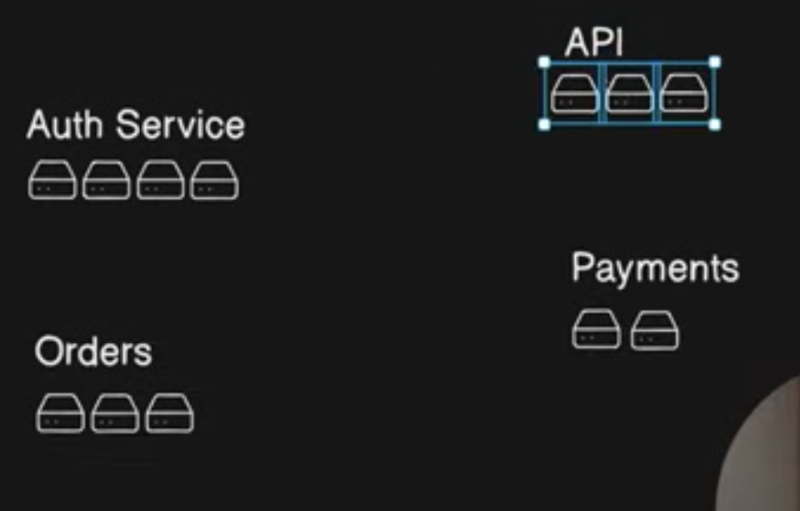  
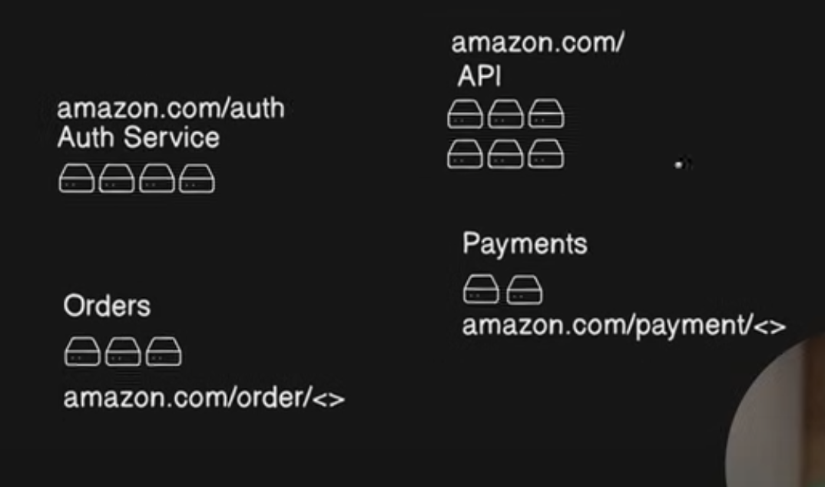

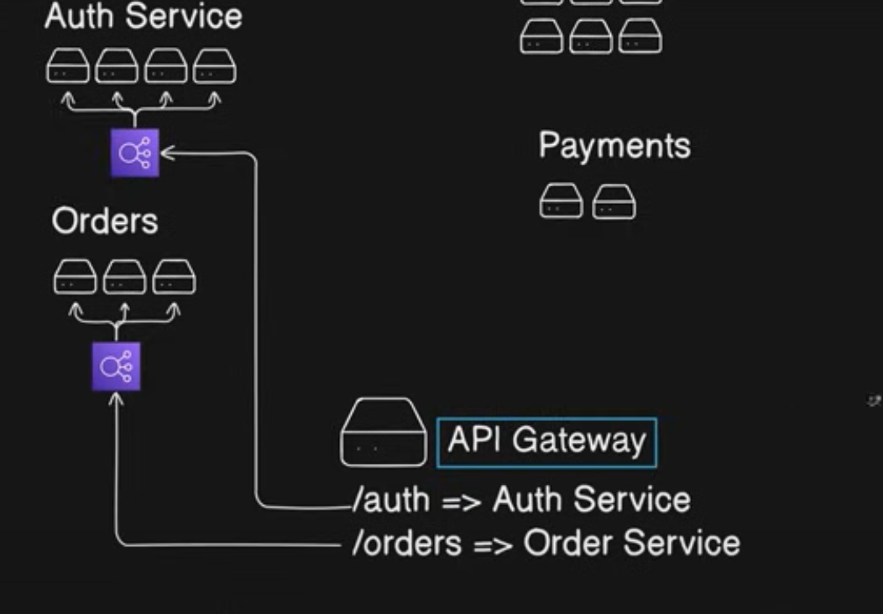

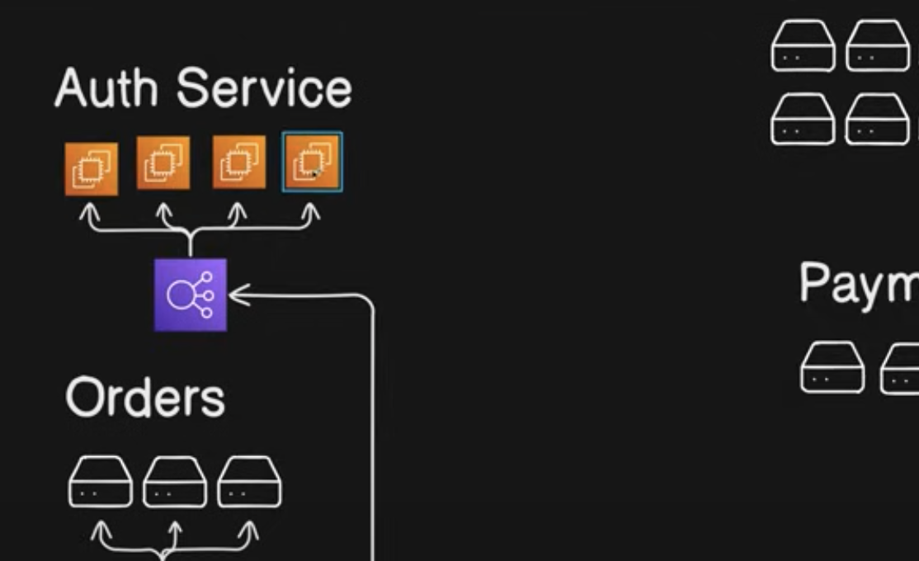

Any request that you make to amazon.com will go to its api getway – 10.5.8.2 something and then api getway will route it to correct load balancer.

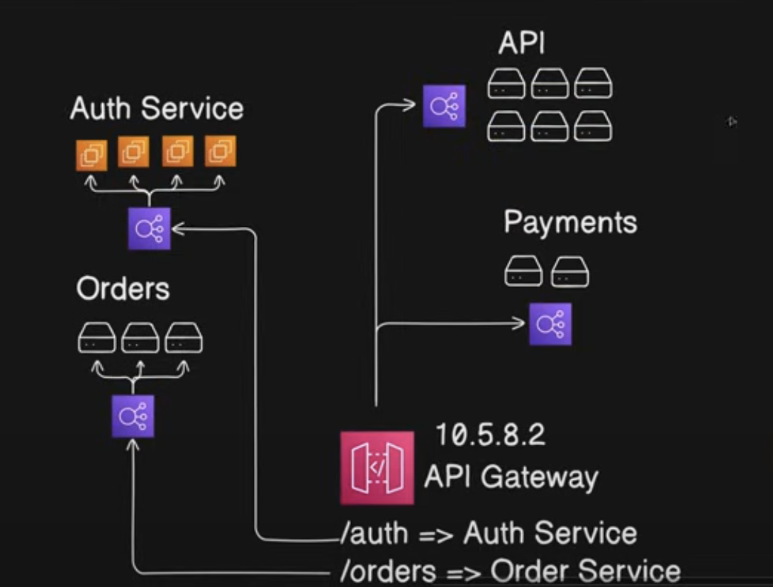

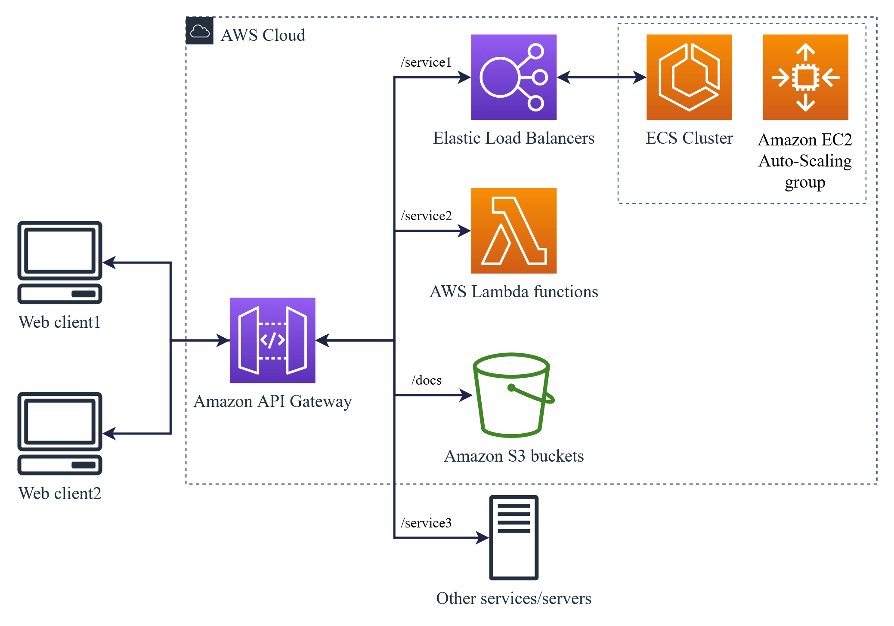

Batch Processing -

Suppose you want to send one million emails to users regarding amazon sale so can you run a loop on server for one million times.

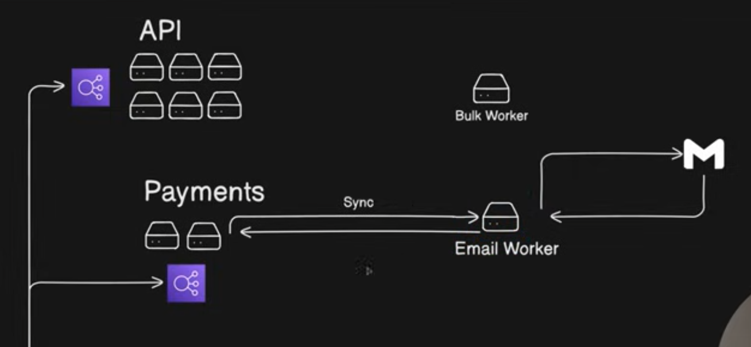

Synchronous and Asynchronous processing.

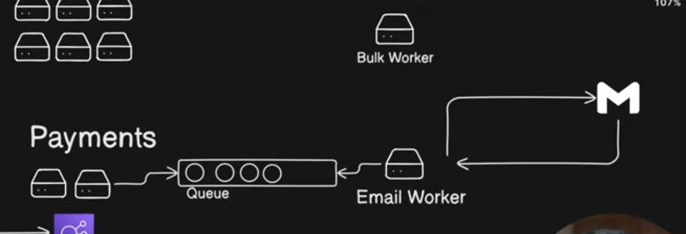

SQS service – simple queue system – one to one hota hai yeh

Dead Letter queue – email was not sent so we add it again in the queue

Poll Mechanism – Email Worker asks the queue system

Push Mechanism – Queue System pushes emails to Email Worker

SQS ke case mein poll mechanism hota hai

Short Pollling(every sec) and Long Polling ( every 10 sec)

CSV queue – user bulk mein upload karde – such as list of users to be inserted into database

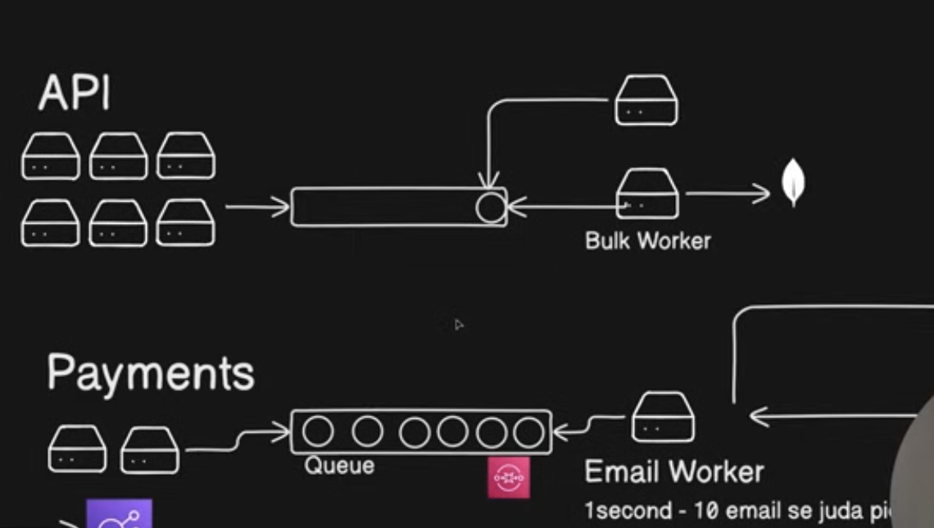

Pub-Sub model – ek event pe aap 4 services invoke karna chahte ho.

One to many

Jaise kisi ne order place kiya toh aap whatsapp pe bhejoge cheezein, email pe, apne app mein update karoge.

Disadvantage. –

There is no acknowledgement.

Above is Even-Driven Architecture

Fan-Out Architecture – to overcome acknowledgement issue

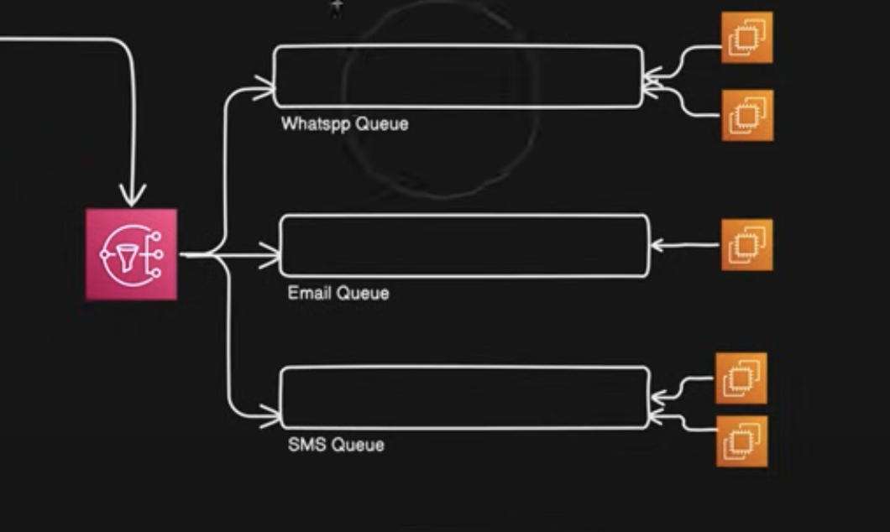

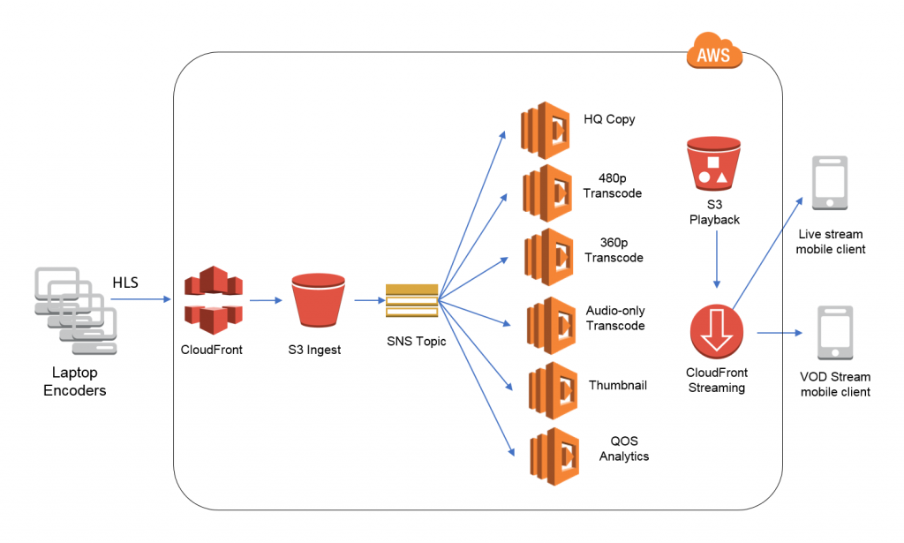

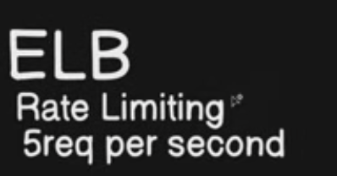

Leaky Bucket, token bucket rate limiting

<https://www.eraser.io/decision-node/api-rate-limiting-strategies-token-bucket-vs-leaky-bucket>

Optimising database load –

1. Primary Node – for insertion

READ replica for analytics and logs and things which can be delayed.

1. Caching

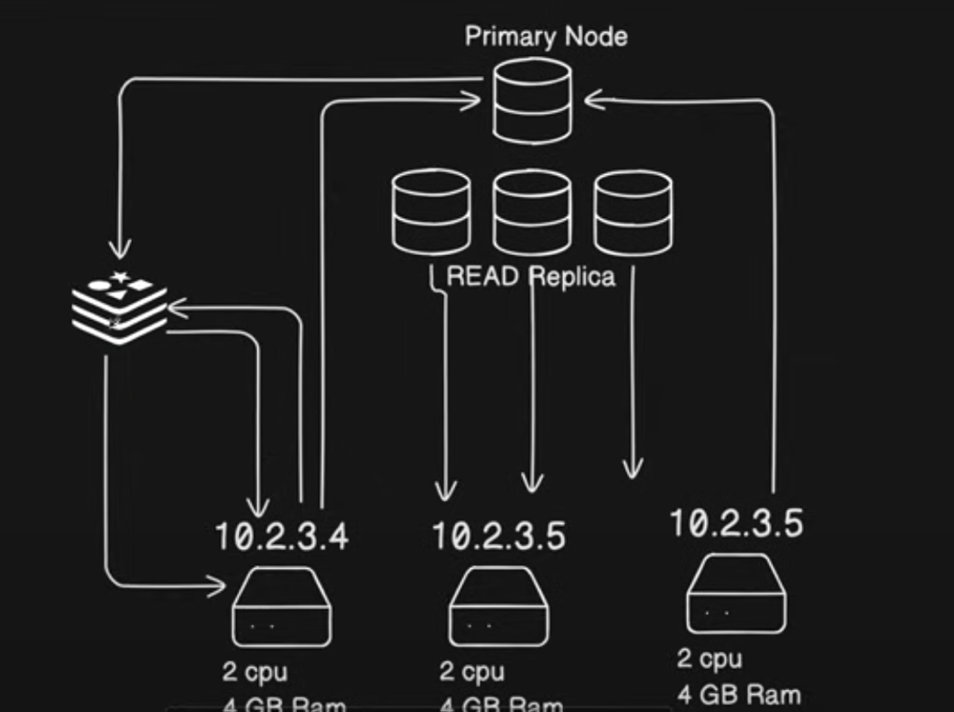

CDN –

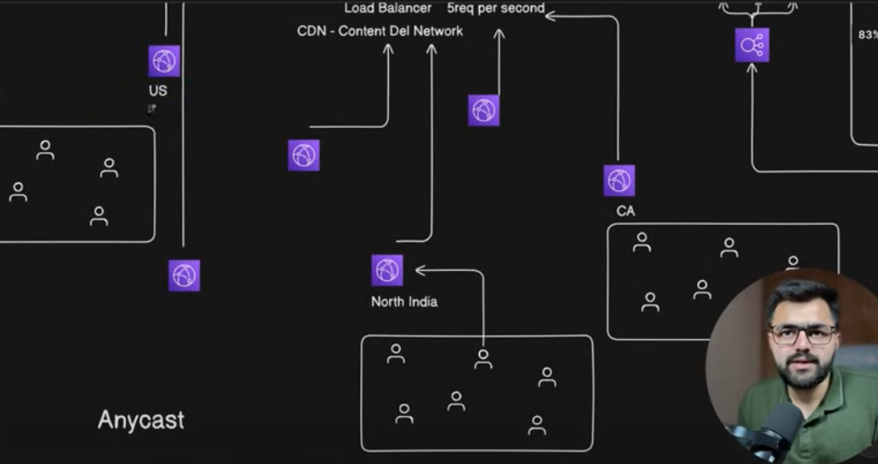

Anycast – A single ip to every machine and user is always redirected to nearest anycast.

Piyush Garg – video 2

Vertical Scaling – more resources e.g. cpu, ram

Horizontal Scaling – more servers

SQS service?

Types of Consistency?  
  
Bulk/Batch Processing

How DNS works?

<https://www.geeksforgeeks.org/system-design/system-design-tutorial/>

System Design time ke saath evolve karta hai.

Har company ka apna use case ke according system design hota.



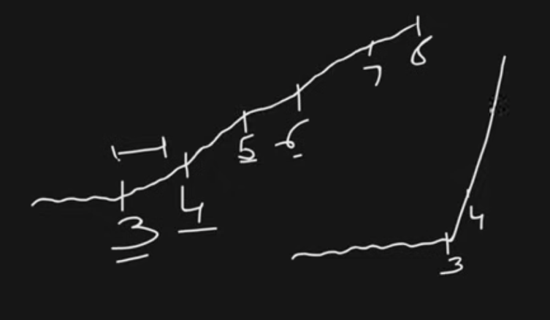

Traffic slowly increasing, easy to handle.

Netflix Design – Traffic is more or less predictable

1. Agar kal movie release hone waali hogi toh ham specific time ke liye servers ka number badha denge
2. Ham first 10 min movie ka cdn mein rakh lenge

Youtube Design –

Traffic is more or less non-predictable

Mr. Beast goes live.

Some earthquake happens.   
these things are unpredictable.  
  
somethings are predictable based on number of subscribers or based on seasons.

Hotstar -

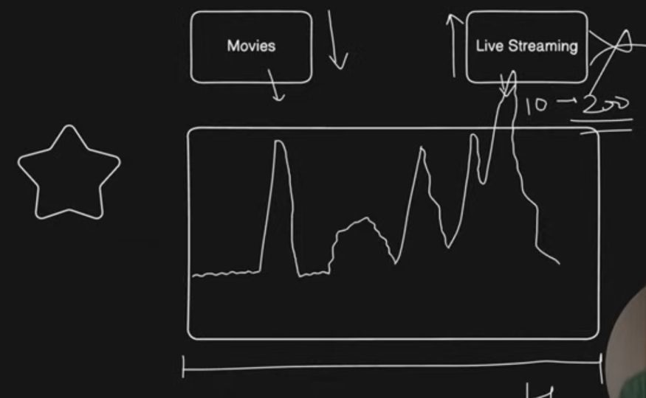

1. Aap auto scaling nahi rak sakhte, aapko spike ka pata nhi hota.
2. Agar koii cricket match se bahar nikalta toh ho sakta hai who movie pe chala jaye toh udhar spike aa sakta

Jab hama naya server add karte hain horizontal scaling mein toh time lagta hai configure karne mein. Phir usko load balancer ke saath register bhi karna hota hai. Toh is time comsuming process se fight karne ke liye lambda/serverless functions aaye.

Serverless – you don’t manage the server

Lambda function – lightweight function

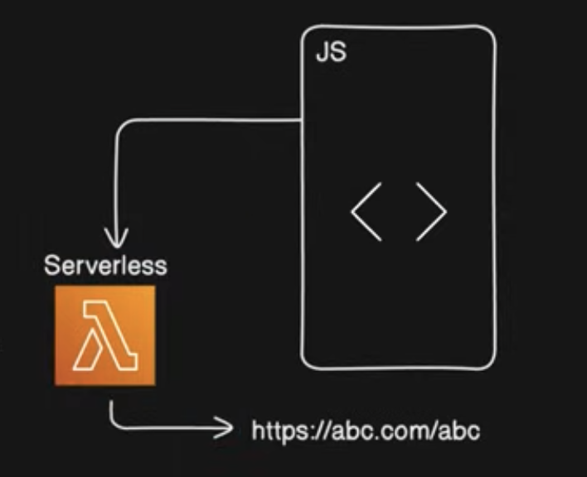

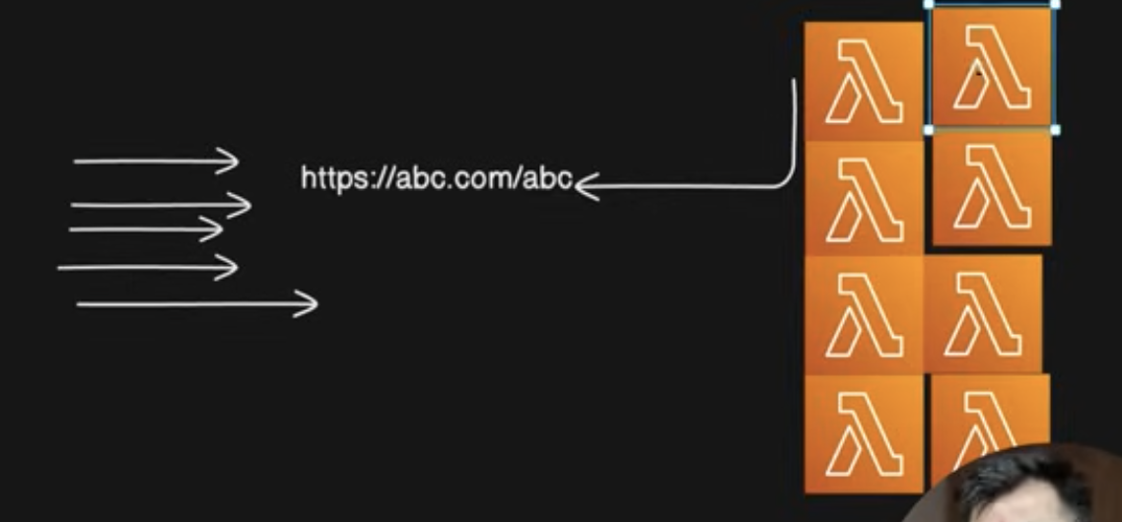

Jab aapke website pe traffic aata hai toh yeh apnea ap chhote lambda functions add hote jaate hain.

Serverless – you don’t manage server.  
Aapko yeh set nhi karna padhta ki kaunsa OS lenge, kitna cpu, kitna ram. Yeh sab serverless manage kar leta hai.

Code likhke upload kardo, who aapko url de denge. Aapko underlying infrastructure use karne ki zaroorat nhi hai.

Lambda downside – cold start

Free tier. –

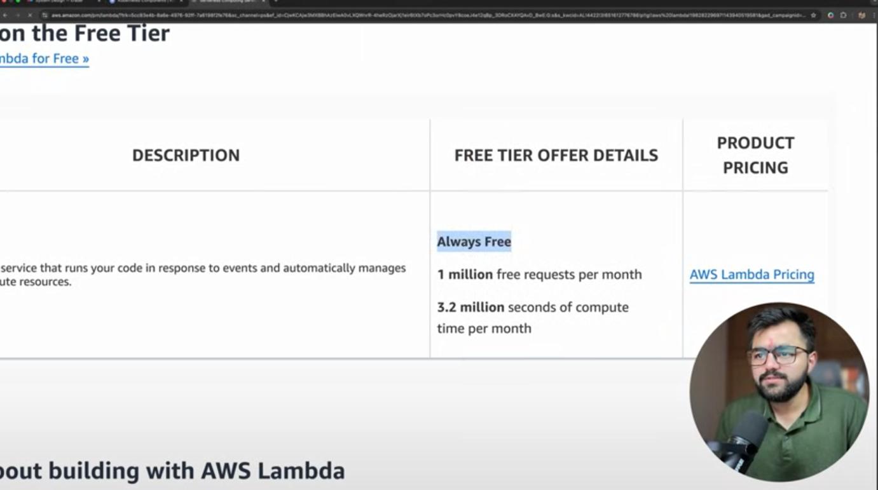

After 1 million requests -

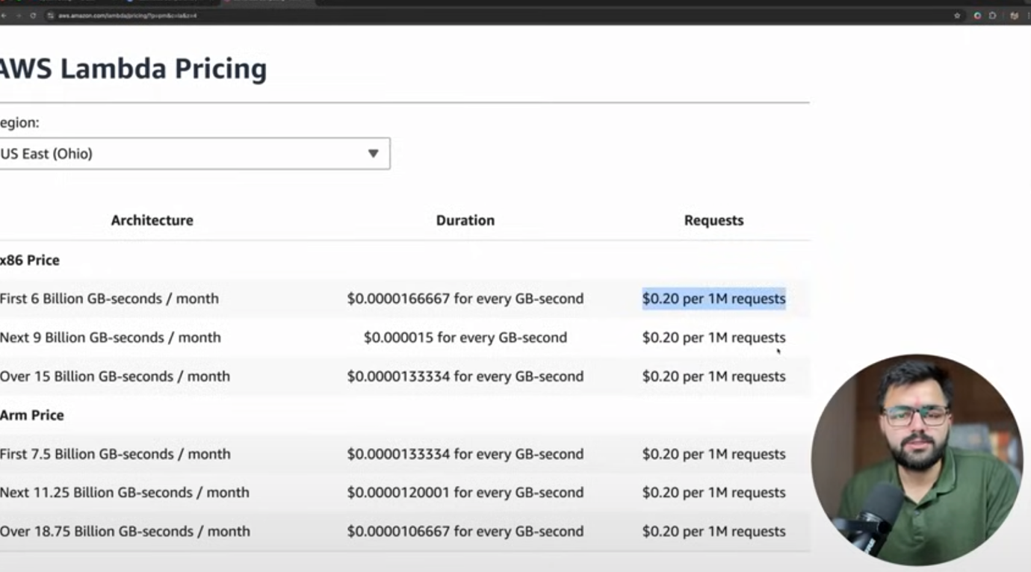

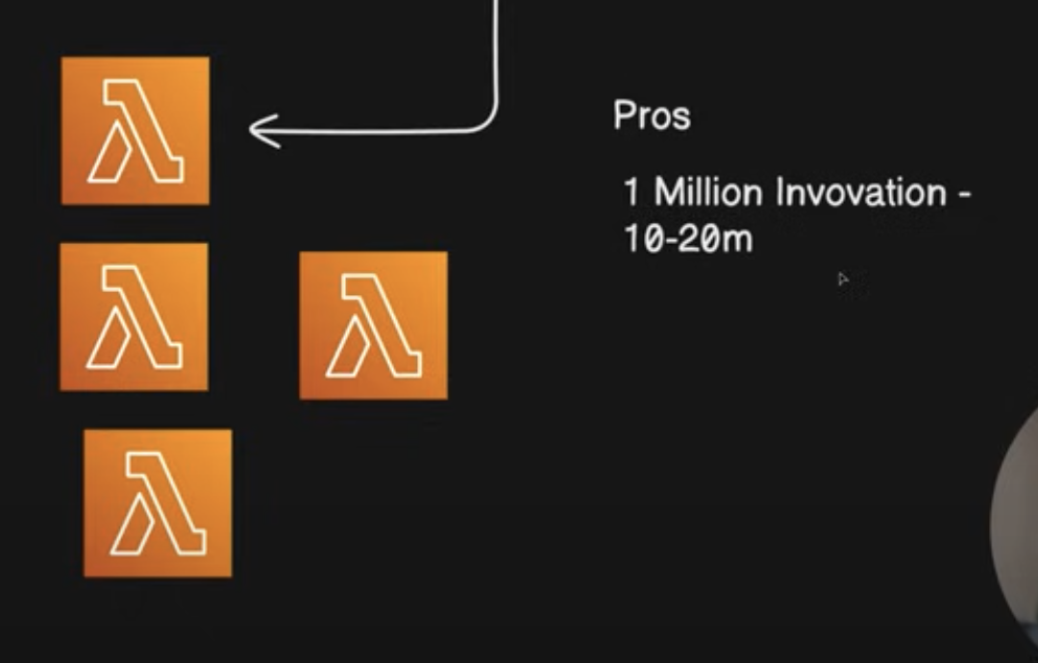

Cons –

1. Cold start
2. Duration Fixed – you cannot take more than 15 seconds to return a request
3. DDOS attack pe infinite scaling
4. Vendor Lock-in – If you want to switch to different cloud, you have to re-structure your entire code
5. When lambda service is invoked, you start using SQS service automatically and you need api gateway to manage it automatically. Then route 53 for domain management. S3 – storage. Logs monitoring – cloud watch. This is vendor lock-in.
6. No-configuration
7. Stateless – you cannot store user data on server because lambda functions destroy automatically.
8. Too many lambada functions – too many mongodb connections – now you need reverse proxy to manage the connections. Now you need stateful machine to manage this.

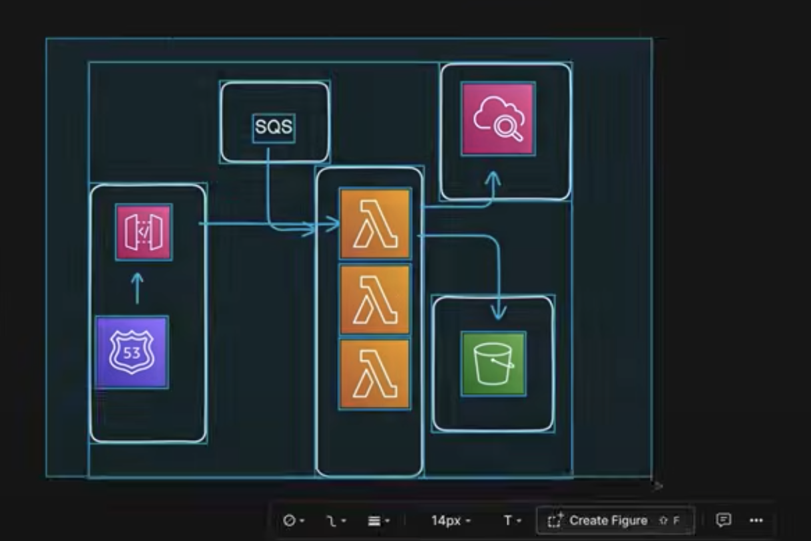

Severless – cloud manages the servers

Serverful – you manage the servers

Ffmpeg – cli tool for video manipulation and transcoding

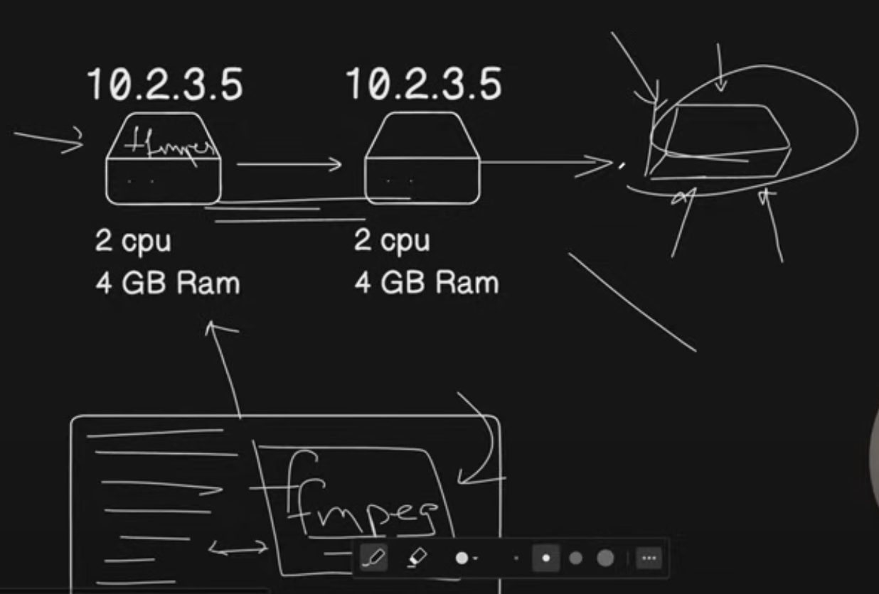

1. SetUp is difficult
2. It Works on My Machine

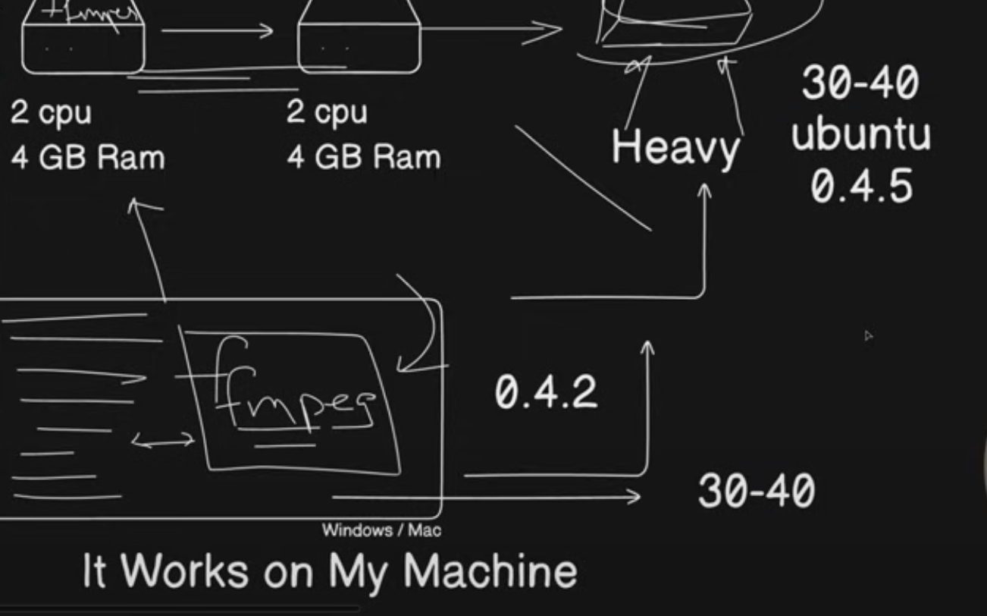

Virtualization – Now it works on any machine

If we use VM –

Cons –

It is heavy

It takes time to scale.

Containerization – lightweight VM.

OS nikaal diya

VM => OS (4gb) , packages(200mb), code (50mb)  
  
we removed OS, so 4gb gone

Scaling becomes seamless.

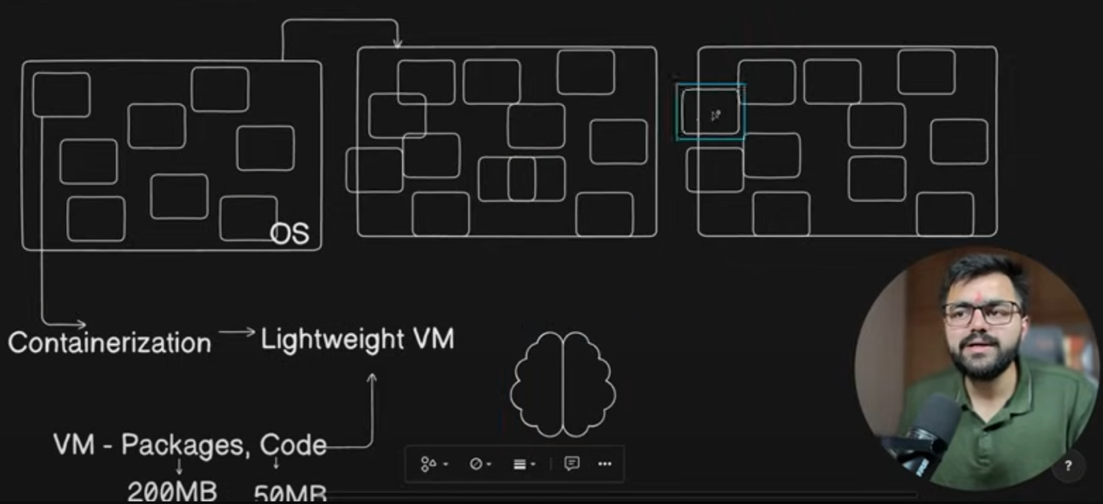

Cons –

It needs a brain to manage the containers

Container Orchestration -

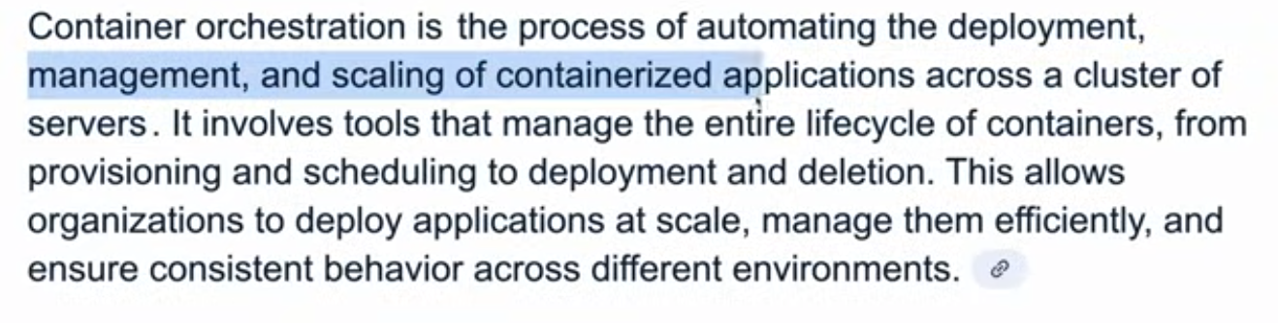

Rolling updated?  
  
Blue-Green deployment?

Google borg – cluster orchestrator

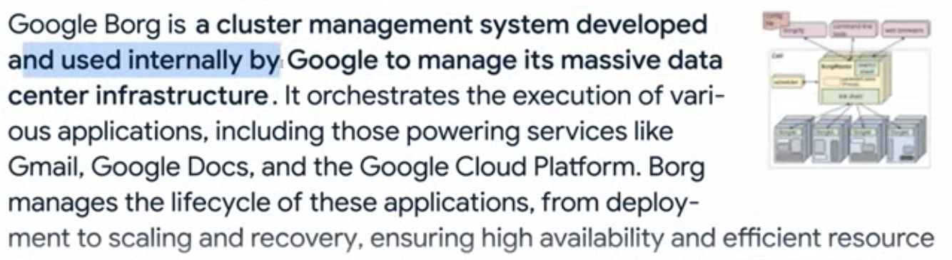

Auto-scaling, auto loadbalacing , everything – orchestrator.

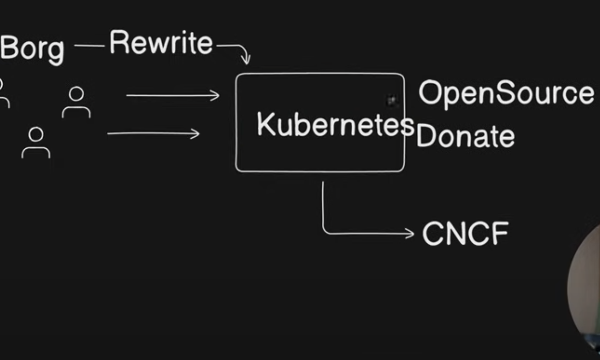

CNCF foundation – holds trademark of kubernets which is created and donated by google.

Kubernetes is built by learnings of borg

Video – 3 Event Sourcing Pattern

Events as the source of truth -

Events -> Event-Driven Architecture -> Event-Sourcing

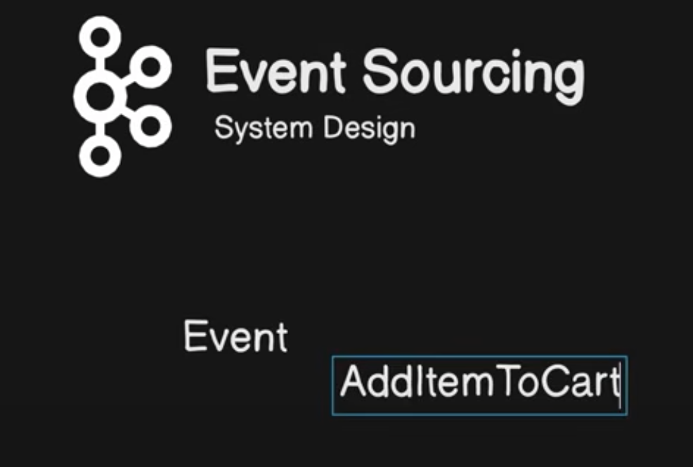

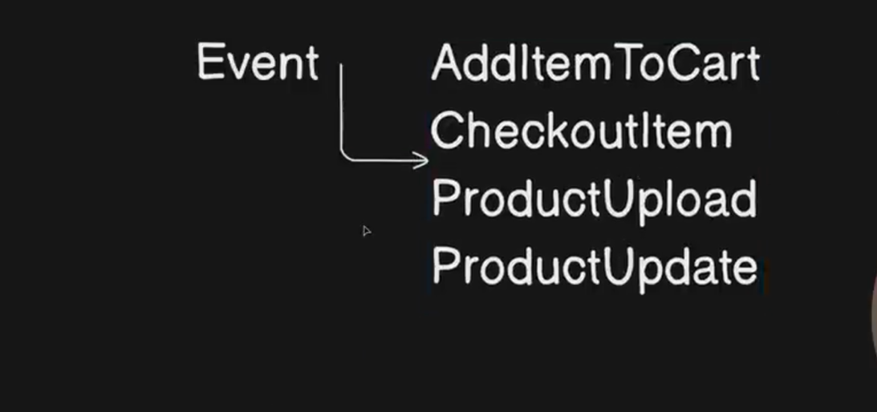

We have different events in our systems as above and for those we perform certain actions on database.

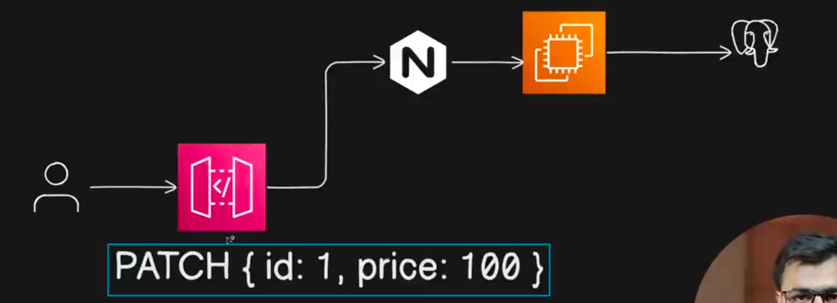

Example – User requested to api gateway to update his product.

Nginx – reverse proxy

Problems –

1. To ensure when you are updating the data, nobody should read it, you put a lock on it. Till then, nobody will be able to read the data from database.
2. State management –

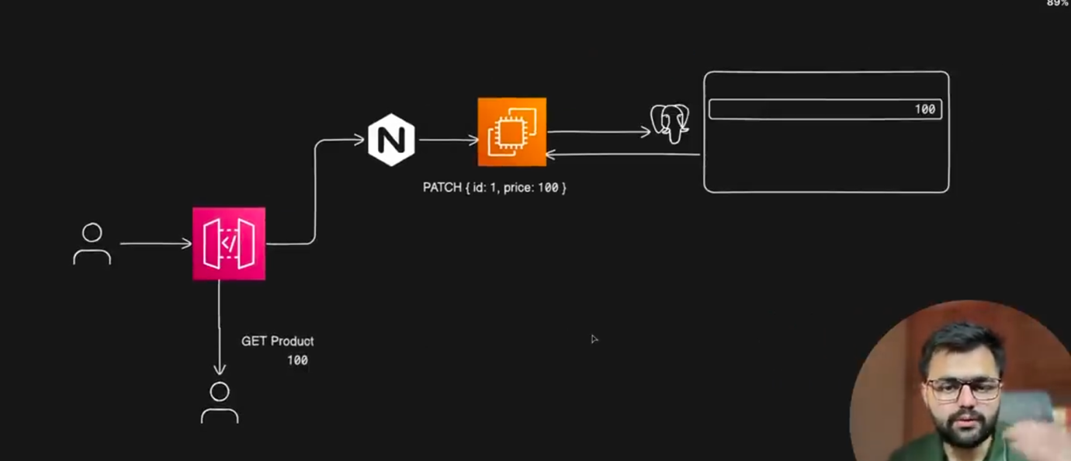

Video Processing Pipeline – Jo youtube hai, videos ko alag alag format mein encode, transcribe and optimize karta hai taaki low-end devices bhi isko dekh paayein.

How to upload an image into AWS S3?

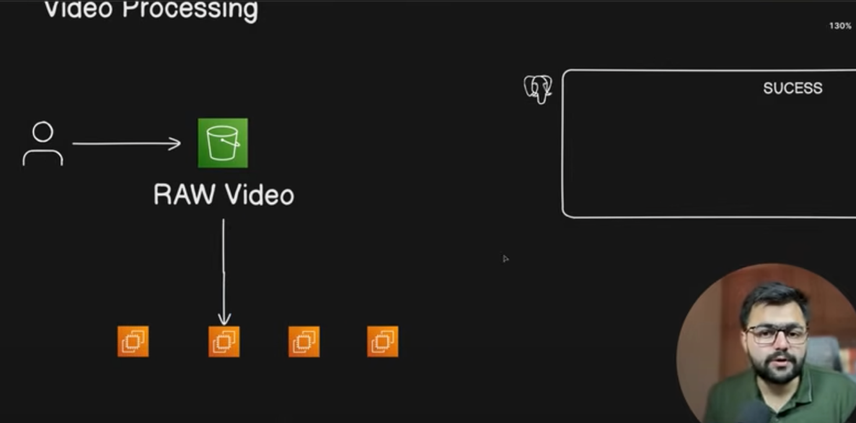

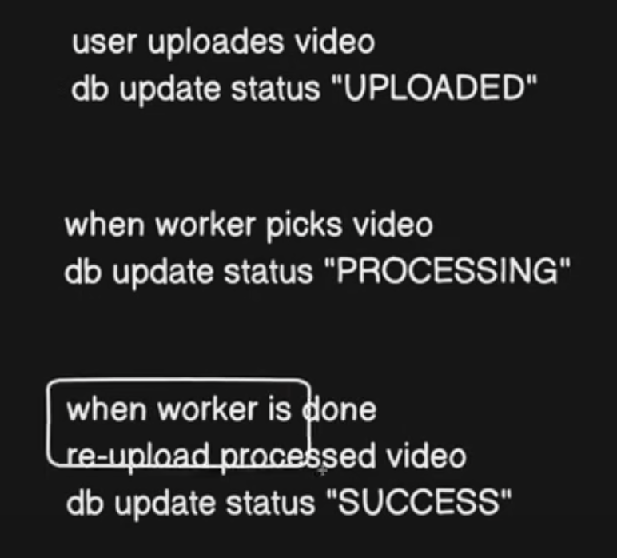

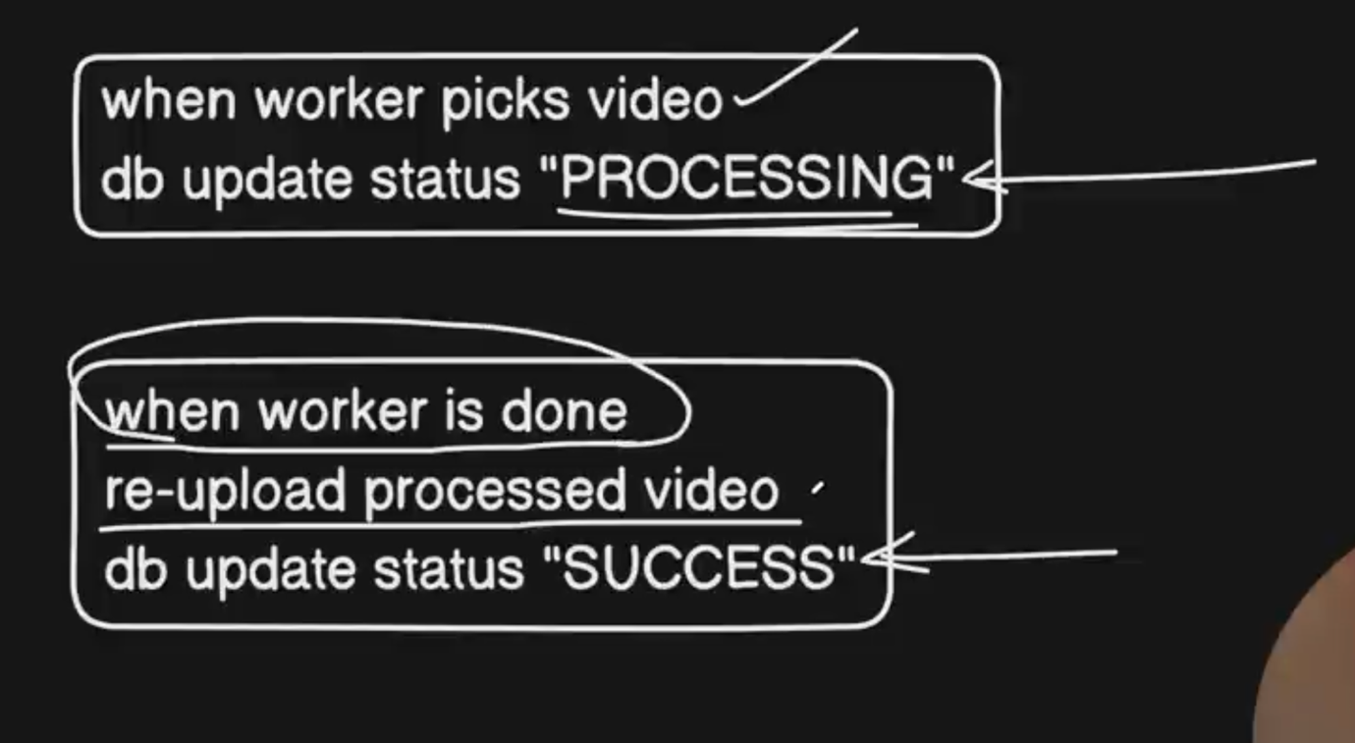

Problem – user uploaded the video but was not able to mark it as uploaded because of some reason.

Query failed because of some database problem.

Atomic Operation – aap replace karte ho states ko.

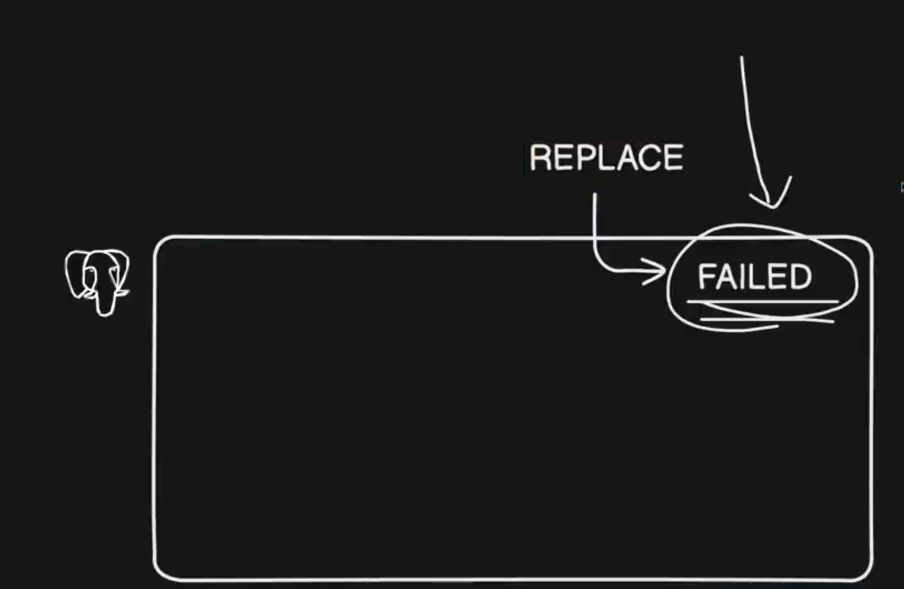

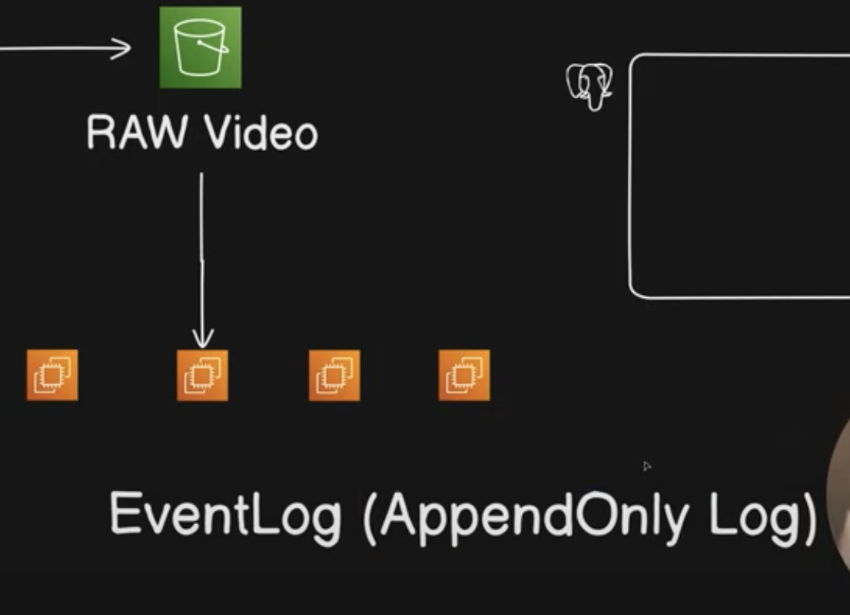

Event – Sourcing => Your source of truth will be events.

Ham kabhi bhi database update nhi karte. Ham events generate karte hain.

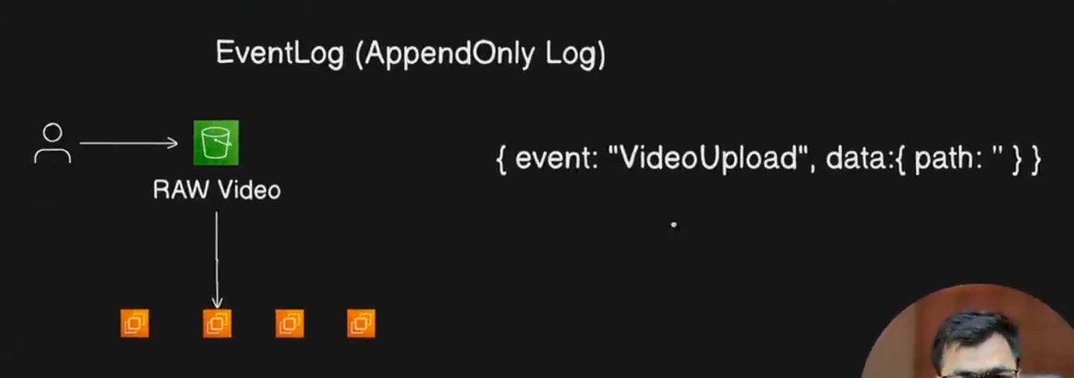

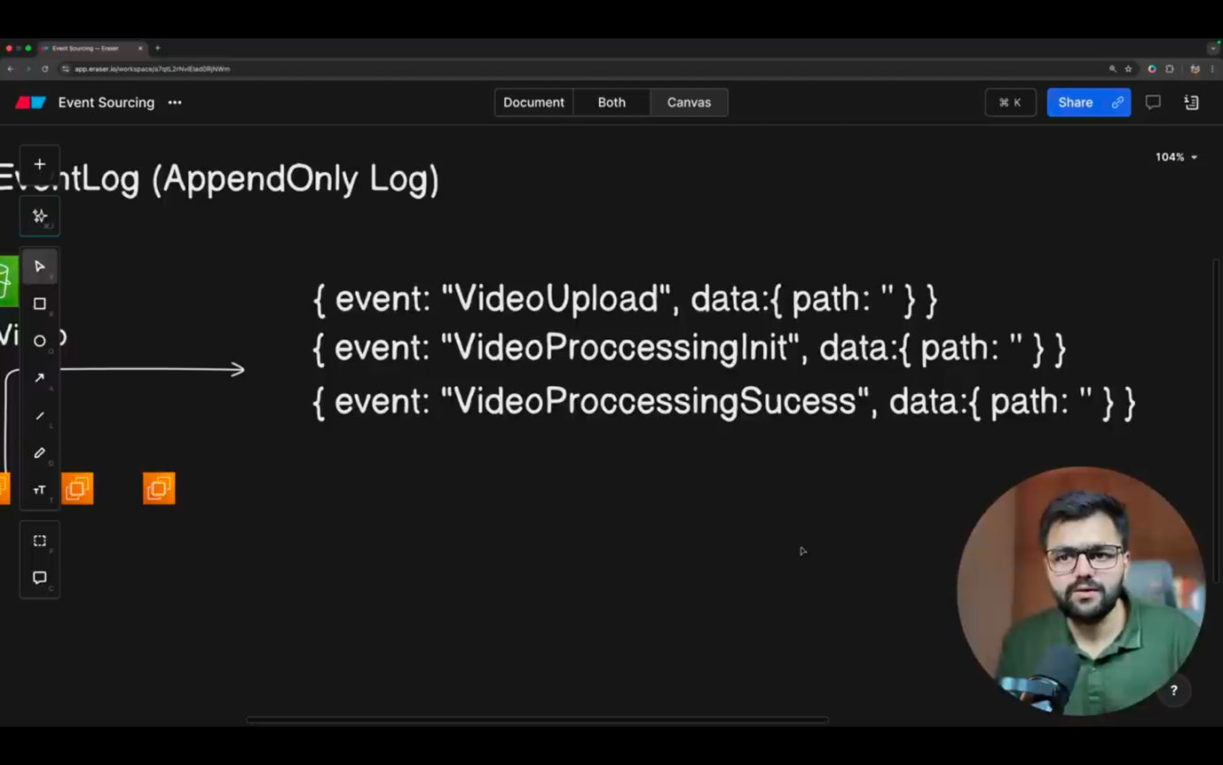

Events stored Rehte hain time stamp ke saath –

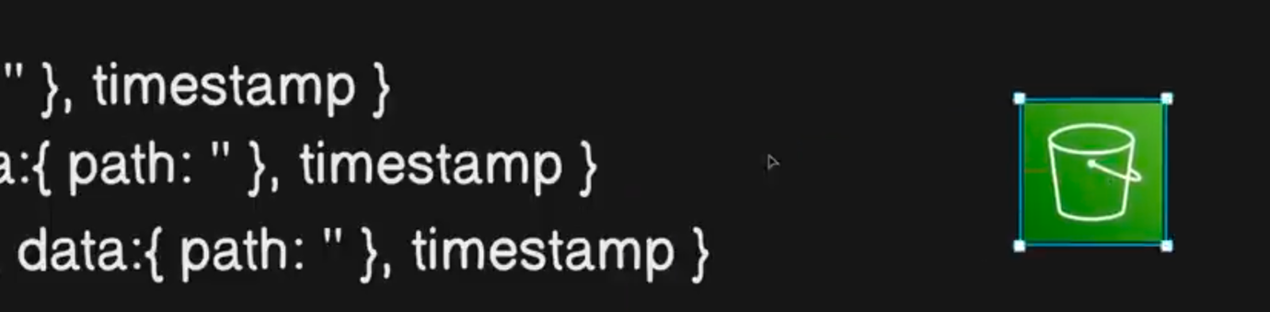

Ham unn events ko re-construct kar sakte hain. Is process ko hydration kaha jaata hai.

Aap user ko dikhane ke liye database ki jageh events ko replay karte ho.

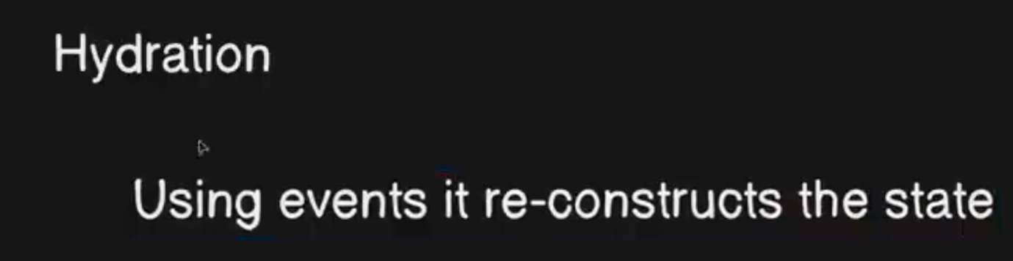

Other examples - Banking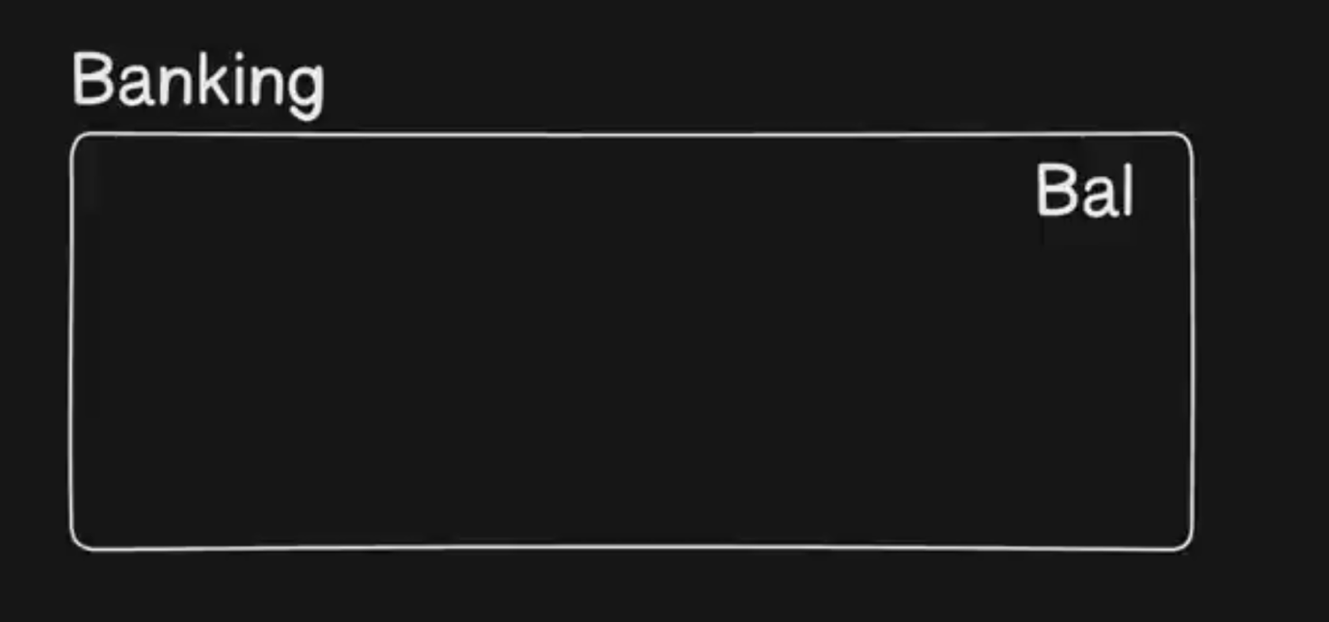

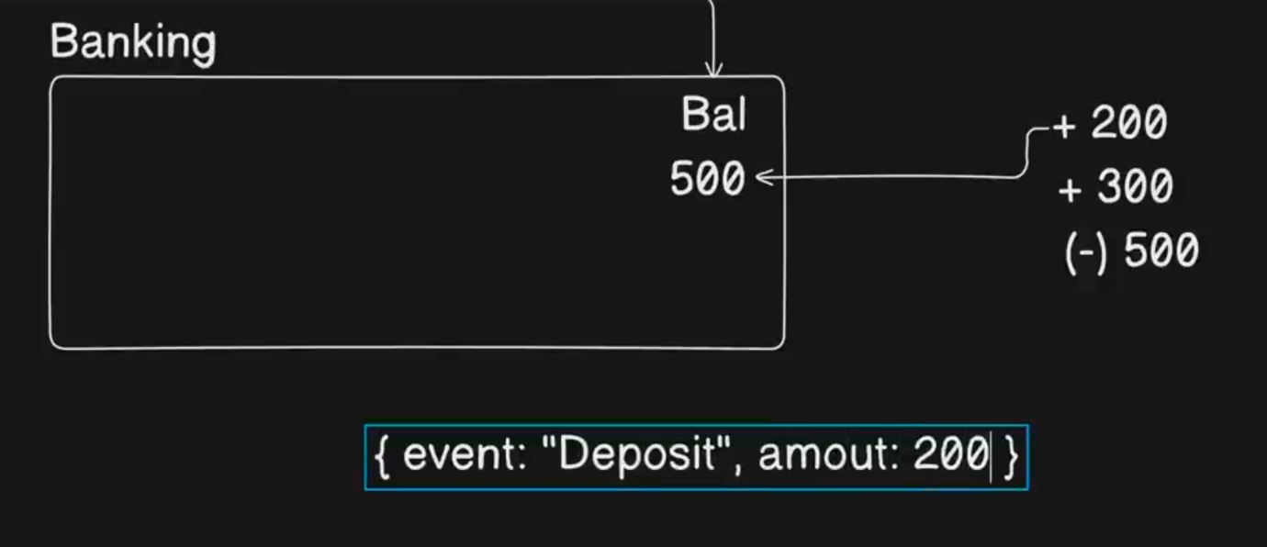

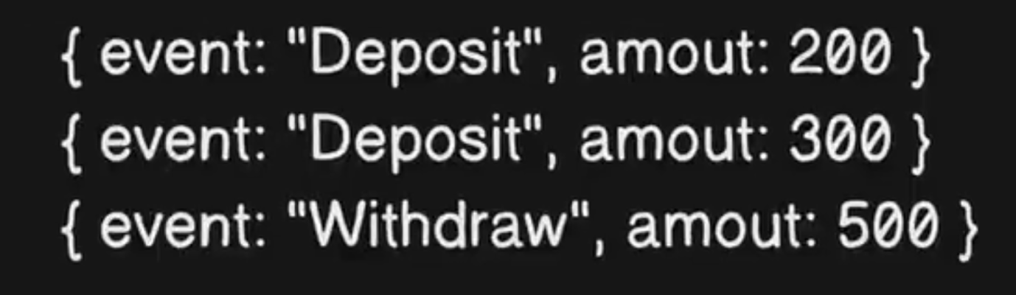

To fetch the current balance of the user – we will use hydration process instead of storing and displaying a column.

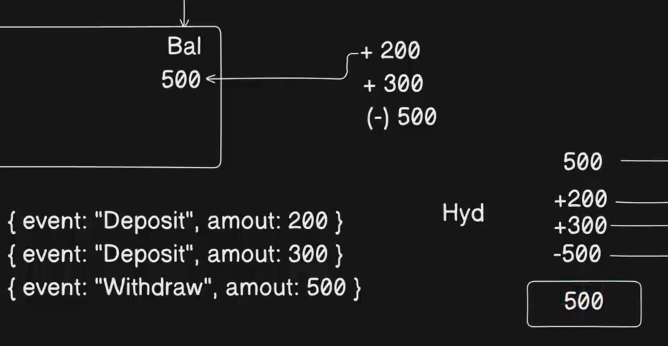

Replay – For Auditing

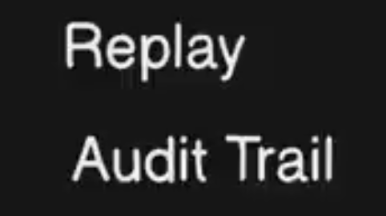

Aaj se ek mahine pehle mera balance kitna tha?

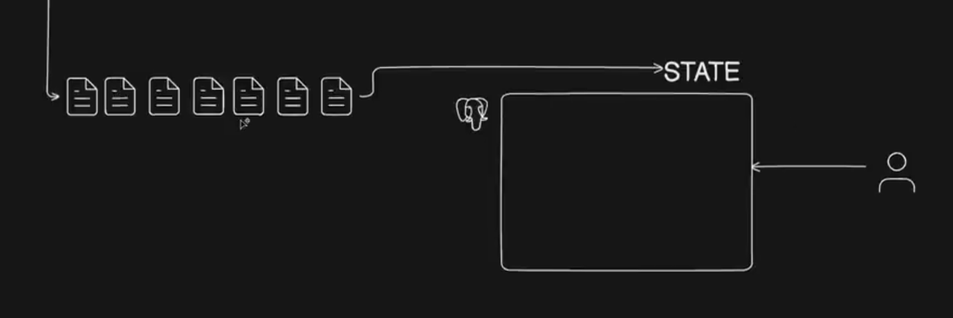

Boht saare events baar run karke state batana bhi inefficient hai toh ham state rakh denge cache karke. Ki mera balance kitna tha and we will use events for auditing purpose.

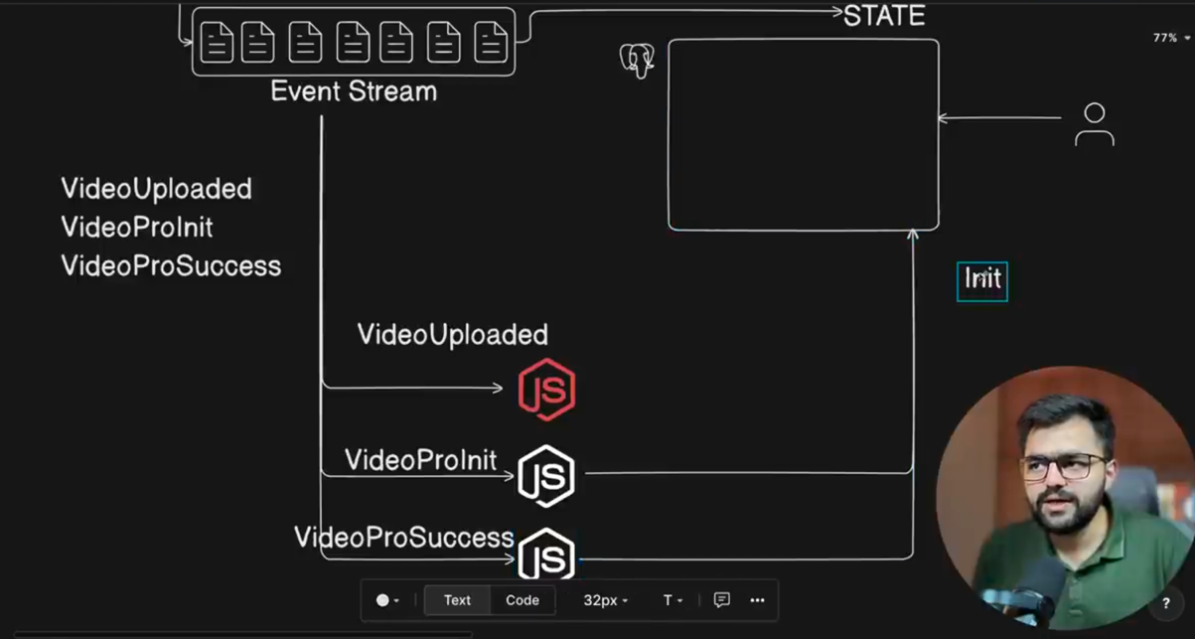

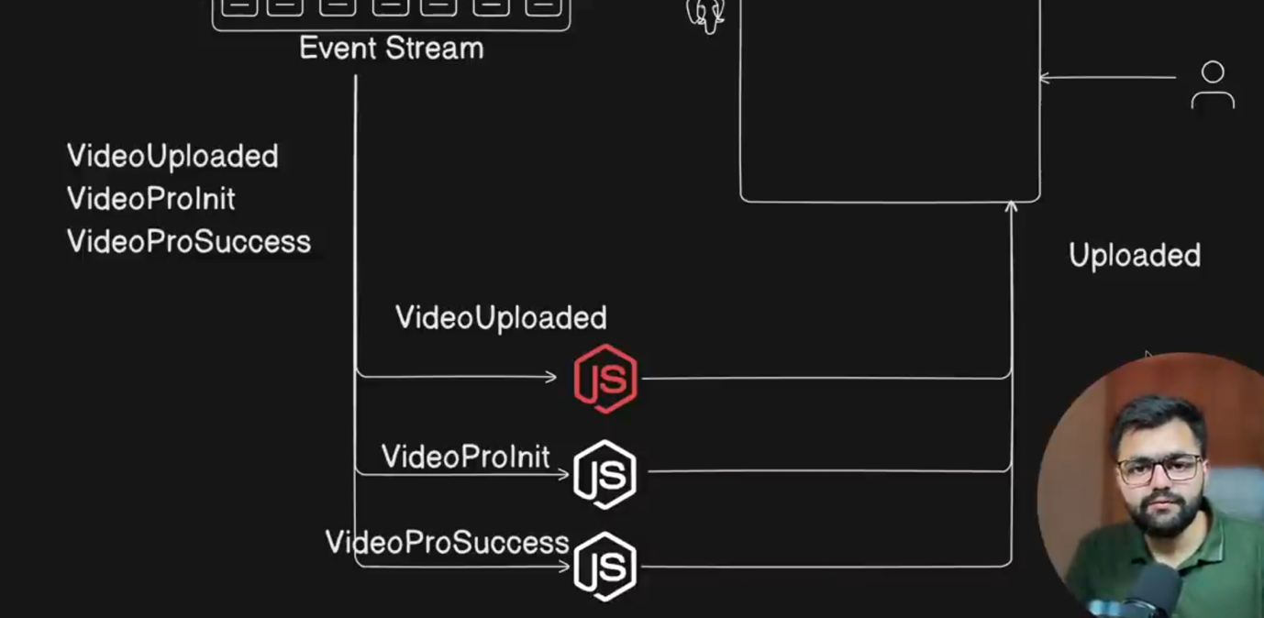

Problem – Though we had event stream, some event completed before the other as multiple event-handlers were involved. i.e. workers went out of sync, “success” state ke baad “uploaded” state likhi gayi DB mein.

Toh ham iss issue se bachne ke liye ek hee handler lete hain.

Kafka – Consumer Groups and Topic Partition

When consumer runs, it subscribes/listens to a specific partition.

Partition is like an Index.

Video A ke events ko worker 0 dekhega. – toh ek sequence rhega.

Video B ke events ko worker 1 dekhega.

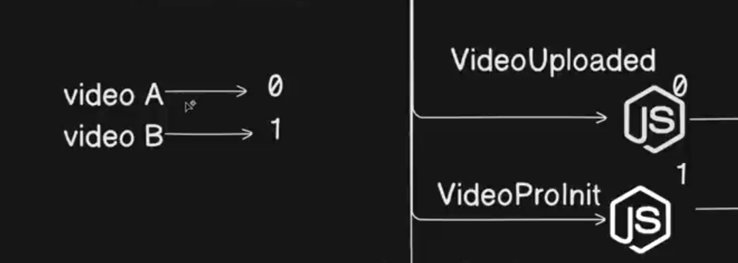

Kafka ke andar hote hain Consumer Groups and Topic Partition to guarantee this.

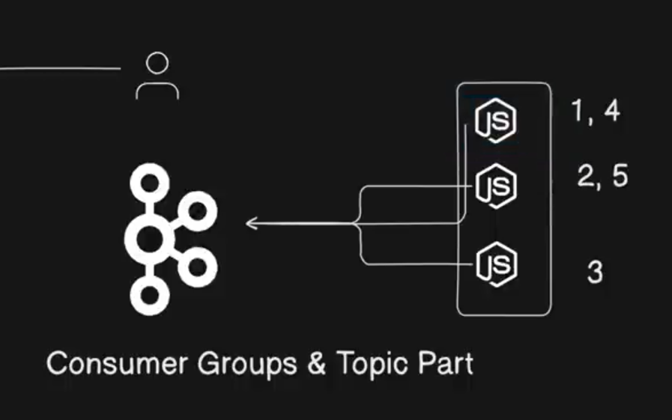

Har event handler ko ek partition ek index diya gya hai (1,4), (2,5), (3)  
toh who handler un indexes ke events ko consumer Karega.

Kafka Guarantees that ki ek particular object ke saare events same server ke pass jayein otherwise you will be having dirty reads.

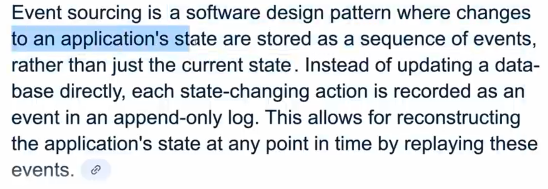

Event Sourcing AWS Blogs.

Event Sourcing Pattern usually follows CQRS.

CQRS – Command, Query, Responsibility, Seggregation.

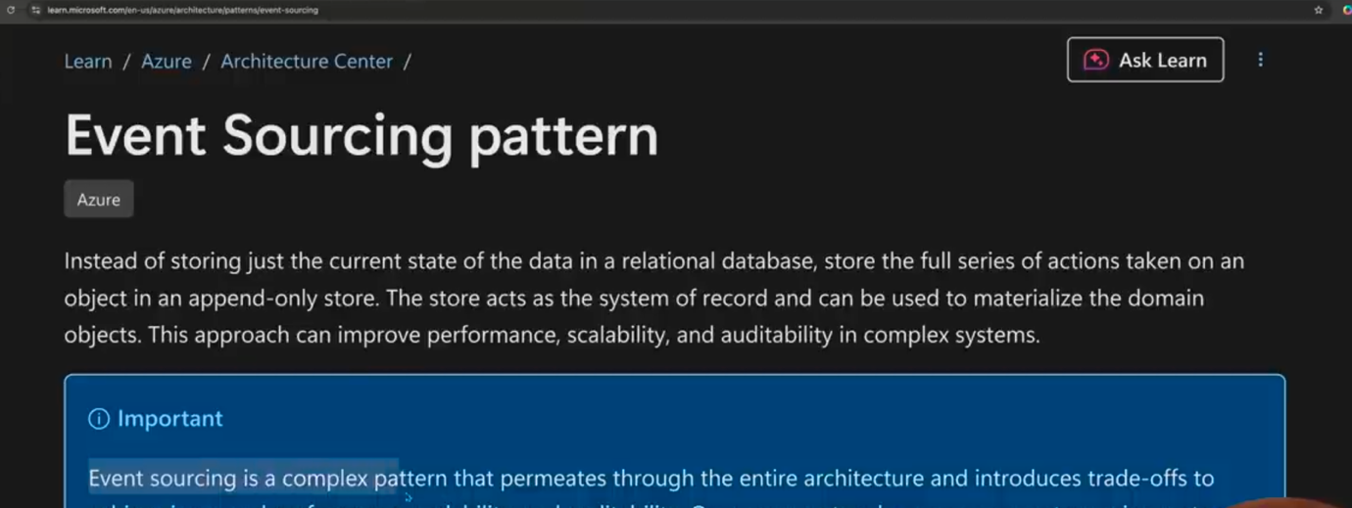

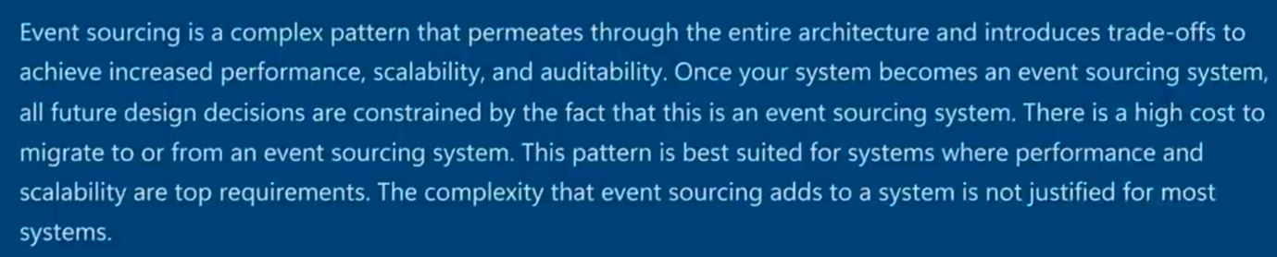

Above articles says that going back is difficult. Aapko architecture update karna padhega.

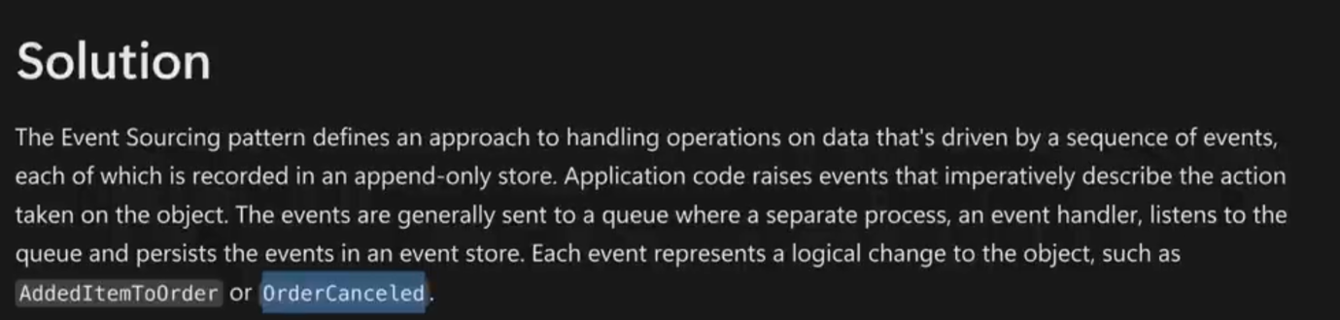

Video – 4 CQRS Pattern

Command Query Responsibility Segregation

How It helps you in scaling your complex applications?

Advanced System Design use these patterns to Optimize database operation

Used in highly complex system.

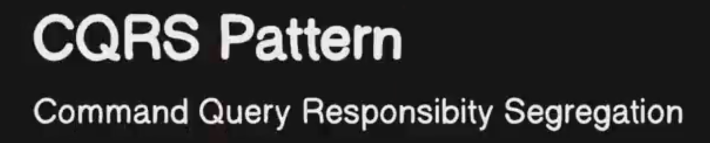

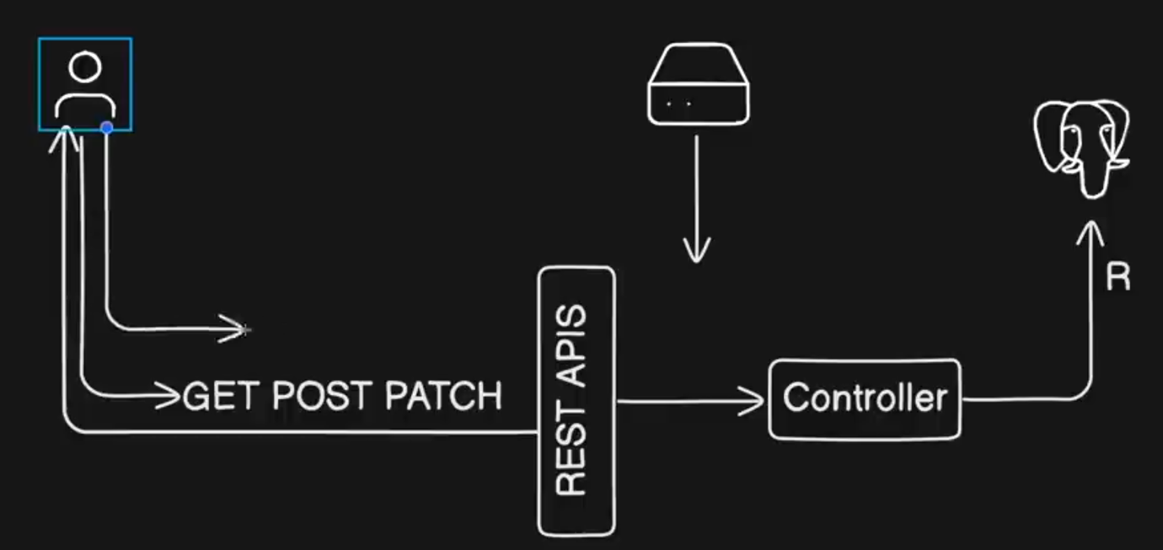

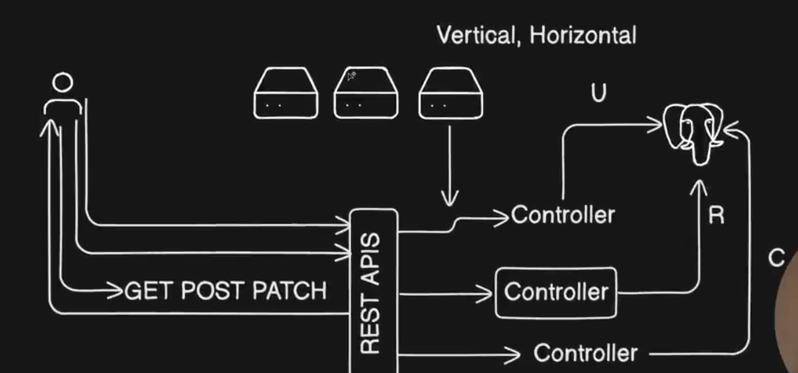

Traditional application architecture.

Jab aap saare operation DB pe perform karte ho tab database overwhelm ho jaata hai.

Vertical and Horizontal Scaling is done on servers.

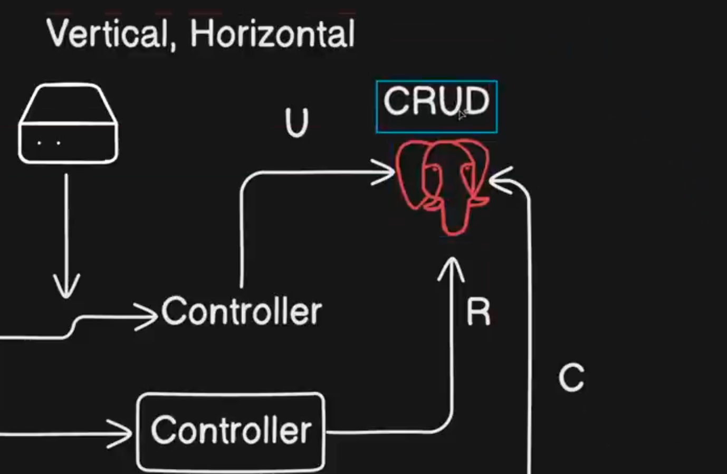

Jab aap update perform karte ho tab aap uske upar ek lock acquire karte ho taaki koii kuchh galat info naa read kar paaye.

Agar aap yeh lock acquire ka kaam frequently karte ho DB pe toh queries both slow ho jayengi. Database bottleneck ban jayega.

To prevent this, we use CQRS.

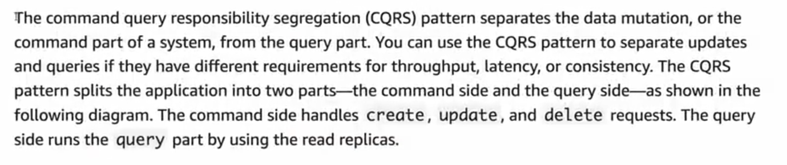

Data Mutation -> Command Part

Query -> Read

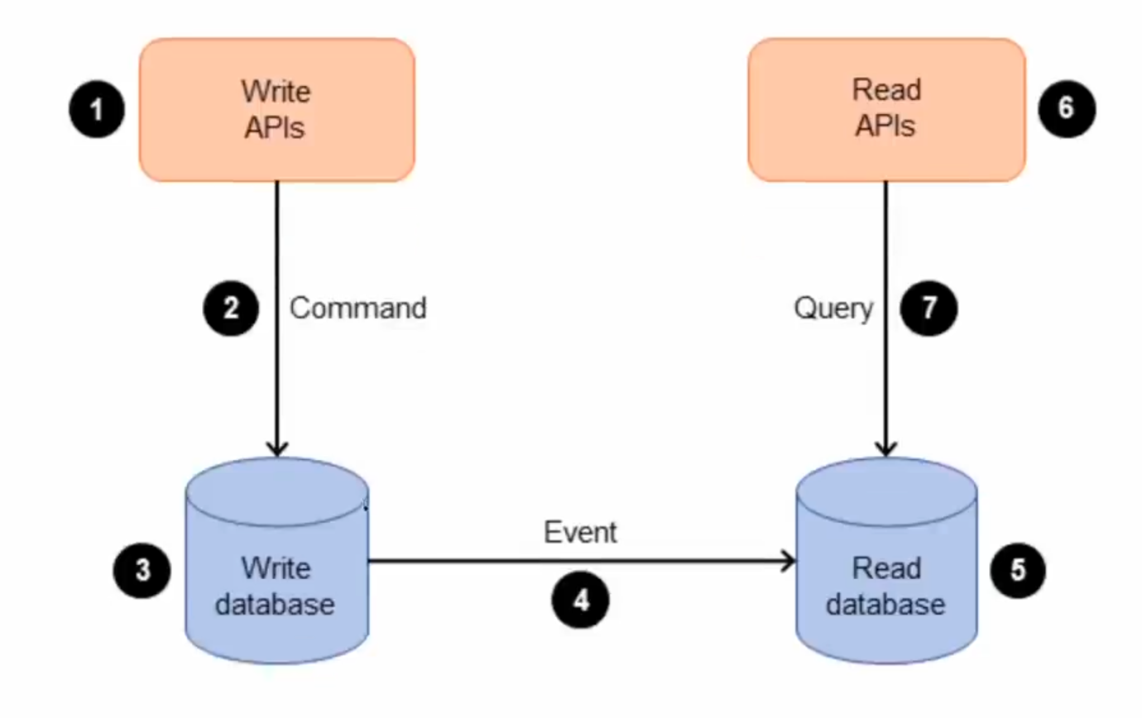

Yaha par 2 alag databases hain read aur write ke liye.

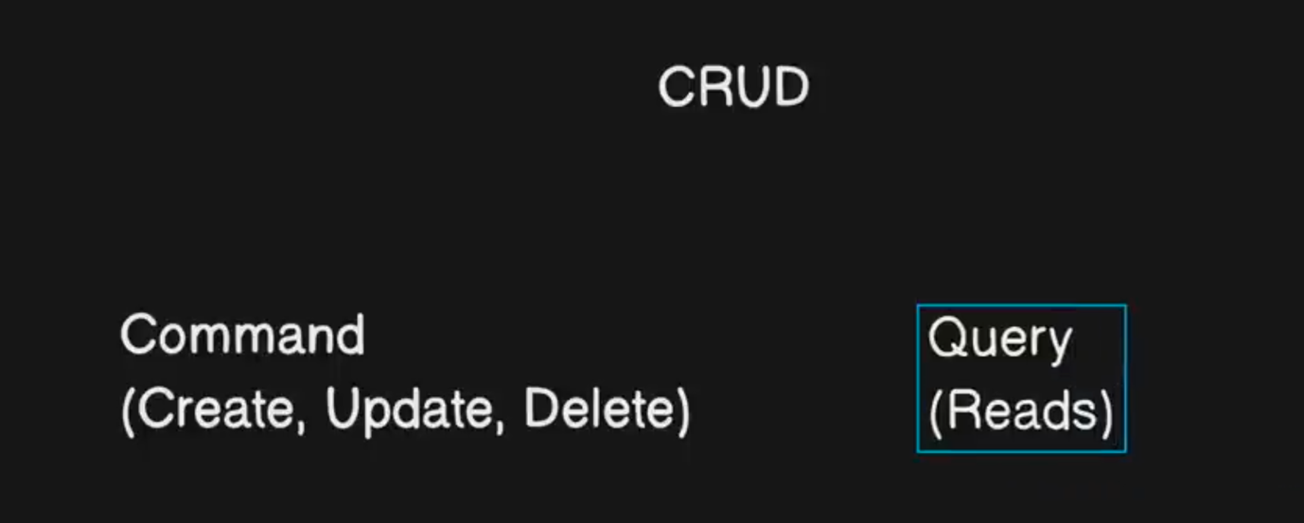

API Gateway acts as a entry point to the system.

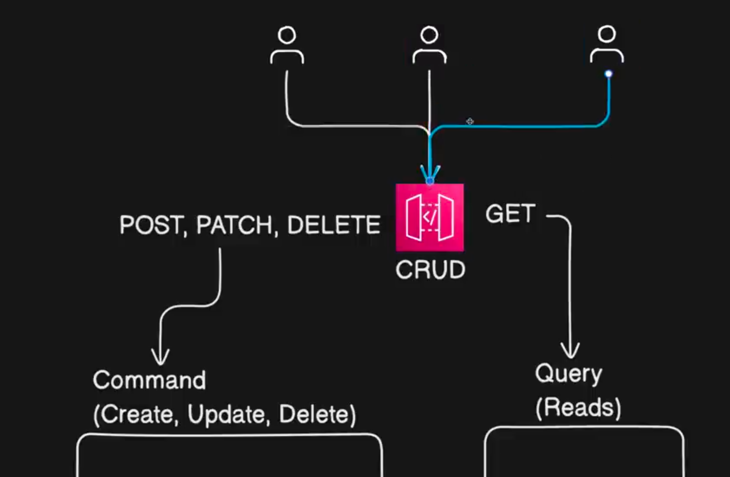

Presentation Layer – UI and Api end points which you expose to the user.

We don’t mutate directly the database.

For each action, we generate a command.

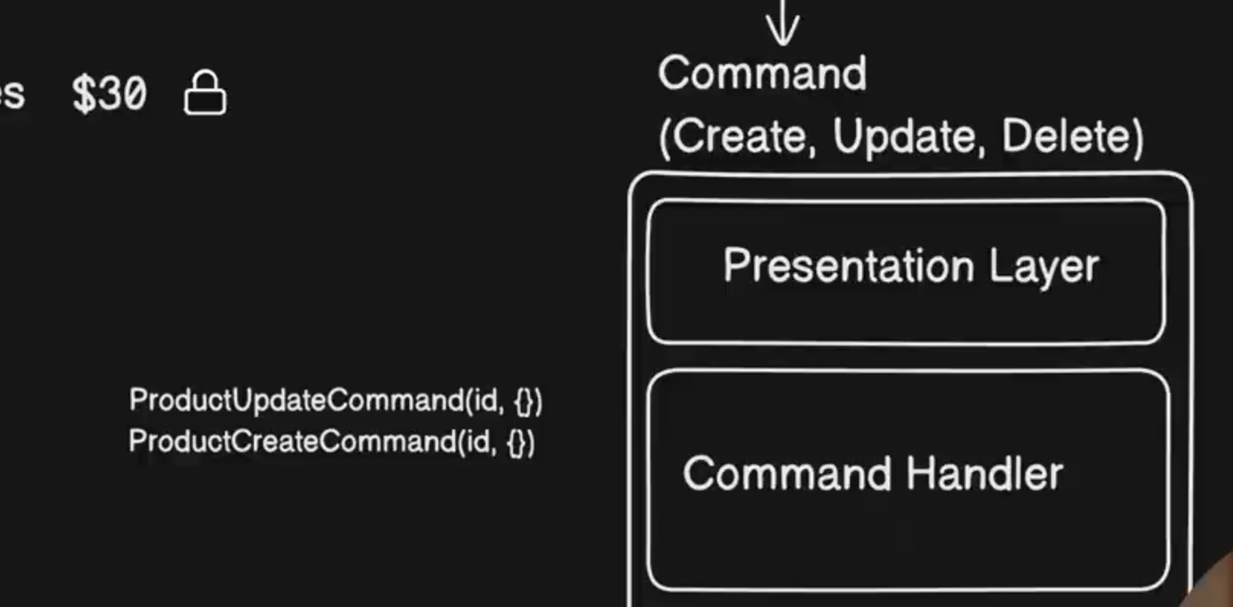

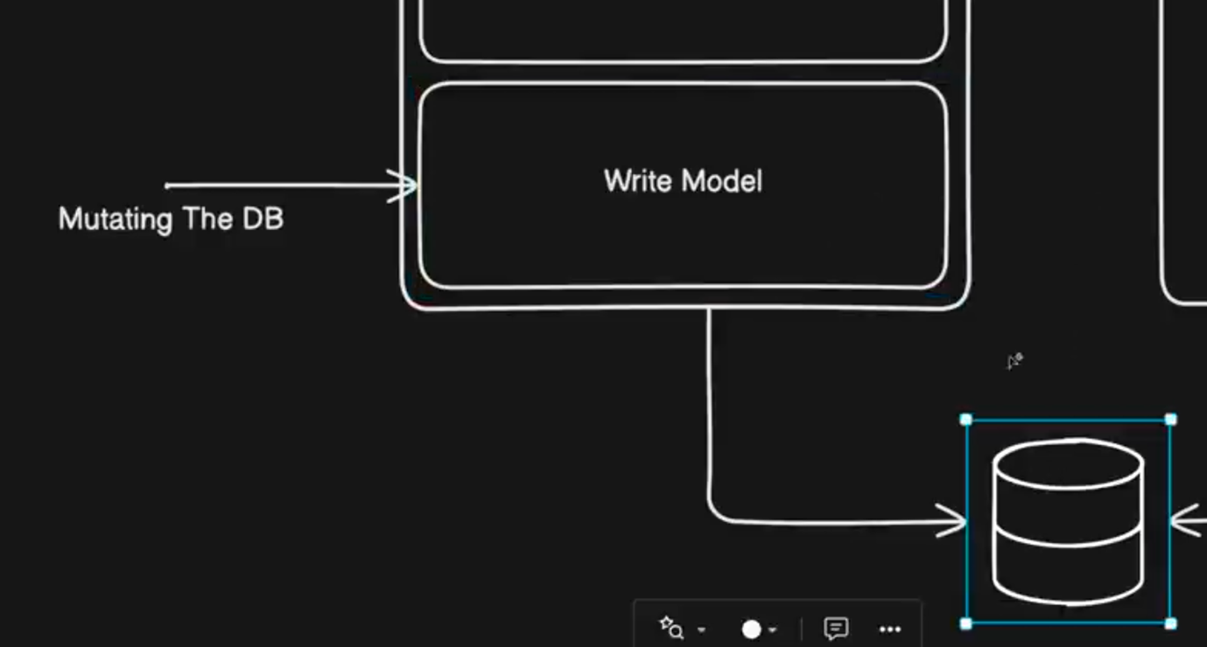

Write Model DB ko update karne ke liye hota hai.

Mutations ke liye ham iss write model ko optimize karte rhenge ki what is the best way to do some operation.

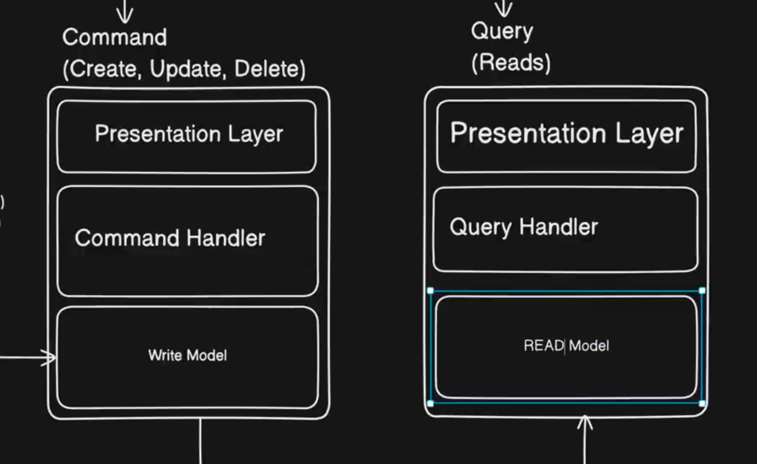

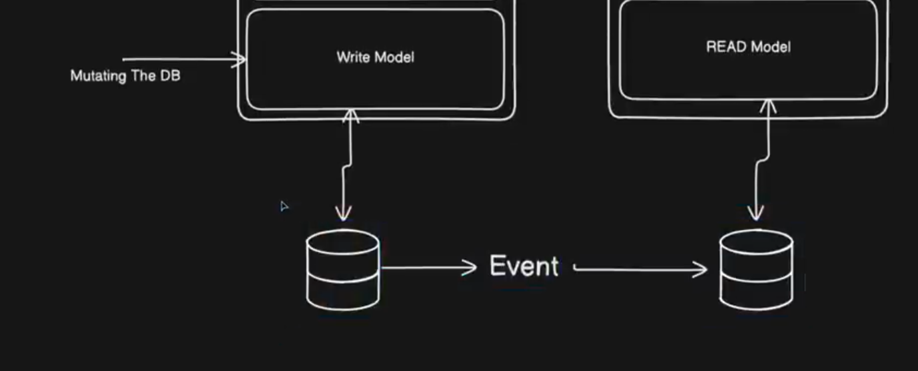

Eventual Consistency.